“RestoFlow – Restaurant Management System”
Developed by
Himanshu D Ladha
Roll no : BCA045
23BCUOS055

Group no : RVP2
Developed at
Invental Data Labs
Ahmedabad
As per
Partial Fulfilment of VI Semester of
Bachelor of Computer Applications
Under the guidance of
Internal guide External Guide
Prof. Rupal Patel Mr Somil Ravrani
Assistant Professor Co-founder
BCA Department Invental Data Labs
Dharmsinh Desai University, Nadiad Vejalpur, Ahmedabad

Submitted to:
BCA Department,
Dharmsinh Desai University, Nadiad

ACKNOWLEDGEMENT

I would like to express my sincere appreciation and heartfelt gratitude to all those who have contributed to the successful completion of this project. I am deeply grateful for the continuous support, guidance, and invaluable contributions that have made this journey both enriching and meaningful.
Firstly, I extend my sincere thanks to the Department of Bachelor of Computer Applications, DDU, for providing me with the opportunity to undertake the project titled “RestoFlow – The Restaurant Management System.” This opportunity has been immensely enriching and has significantly enhanced my practical knowledge and technical skills. The department’s support, encouragement, and provision of necessary resources were instrumental in the successful completion of this work.
I am deeply thankful to Mr. C. P. Patel, Head of the Department, and all esteemed faculty members for their constant guidance and support throughout the project development. Their expertise and academic insights have played a pivotal role in shaping this work.
I would like to place a special note of appreciation to Mr. Somil Ravrani for his mentorship and encouragement, which have been a great source of motivation throughout this project. His valuable insights and professional guidance were instrumental in refining and enhancing the overall quality of this work.
I also extend my sincere gratitude to Prof. Rupal Patel, my internal guide, for her continuous support, patience, and technical expertise. Her valuable suggestions and consistent guidance were crucial in overcoming challenges and ensuring the successful execution of this project.
Lastly, I express my deepest gratitude to my family and friends for their unwavering encouragement and moral support. Their belief in my abilities has been a constant source of strength and motivation throughout this journey.
This project would not have been possible without the support and contributions of everyone mentioned above. I remain truly grateful for their guidance and encouragement, which made this experience both successful and memorable.

Thank you Everyone,
Himanshu D Ladha 23BCUOS055

TABLE OF CONTENTS
Sr. No | Content | Page No
1 | About the System
2 | Organization Overview & Chart
3 | Hardware and Software Configuration
4 | Features of the Tools Used
5 | Detailed Description of System  a. Existing System  b. Proposed System
6 | System Documentation  a. Feasibility study  b. Timeline chart  c. Use Case diagram  d. Data Flow diagram  e. Entity Relationship diagram  f. Data Directory  g. Screen Layouts – with description  h. Testing
7 | Scopes and Limitations
8 | Future Expansion

CHAPTER – 1
ABOUT THE SYSTEM

ABOUT THE SYSTEM

RestoFlow is a modern, QR code–based food ordering and restaurant management platform designed to simplify and enhance the dining experience. The system allows customers to scan a QR code placed on their table to access the digital menu of the respective restaurant. Through this interface, customers can conveniently browse menu items, place orders directly from their table, and complete secure online payments before the order is processed.
The platform supports real-time payment processing and enables customers to track the live status of their orders, ensuring transparency and improved customer satisfaction. By eliminating the need for physical menus and manual order-taking, RestoFlow enhances operational efficiency and reduces waiting time within the restaurant.
On the administrative side, the Restaurant Admin has full control over restaurant operations within the system. They can add, update, and delete food items, manage table information, and monitor customer orders efficiently. This ensures smooth day-to-day management of restaurant activities.
Additionally, the system includes a Main Admin module, which oversees the entire platform. The Main Admin can manage restaurants and customers, including adding, updating, and deleting restaurant records and food items. This centralized control ensures proper regulation, data management, and overall system administration.
Overall, RestoFlow integrates customer convenience with efficient restaurant management through a secure, real-time, and user-friendly digital platform.
The system leverages technologies such Backend developed using ASP.NET Core (.NET 8) and Frontend developed using React ensuring smooth performance, scalability, and responsiveness across devices including desktops, tablets, and smartphones. The integration of secure authentication and dynamic menus and secure payment integration make the system reliable and user-friendly.

Objective:
The primary objective of this system is to simplify restaurant ordering through QR-based digital interaction using mobile devices.

Types in this system:
1. Admin
2. Restaurant Admin
3. Customer/ User

CHAPTER – 2
ORGANIZATION OVERVIEW & CHART

Organization Chart

CEO,CTO & Co-Founders

HR
Project Manager

Developer/Coders

Organization Overview

Invental Data Labs IT Solutions was founded in 2018 with the goal of providing high-quality IT services to businesses of all sizes. Since then, we've grown into a trusted partner for hundreds of companies, helping them navigate the ever-changing technology landscape.
The team of experienced IT professionals is dedicated to delivering the best possible solutions for our clients. We believe in continuous learning and staying up-to-date with the latest technologies.
At Invental Data Labs IT Solutions, we value teamwork, collaboration, and a positive work environment. We are committed to providing an inclusive and supportive workplace for all our employees.
Services:
- Web design
- Web development
  - .Net
  - React JS
- Product Management
- Marketing
- Graphic Design

CHAPTER – 3
HARDWARE & SOFTWARE CONFIGURATION

Hardware & Software Configuration
Hardware Configuration/Requirement Server Side
Hardware Configuration
Processor | Intel core i3
RAM | 8GB
ROM | 128GB
System Type | 64 bit

Software Configuration/Requirement Server Side
Software Configuration
Operating System | Windows 10 or higher
Browser | Microsoft Edge, Google Chrome, etc
Database | SSMS

Hardware Configuration Client Side
Component | Minimum Requirement | Recommended Requirement
Processor | Intel core i3 | Intel core i3
RAM | 2GB | 4GB
Storage | 5GB free space | SSD recommend for more better performance
Internet | 2mbps broadband or higher | 10mbps better

Software Configuration Client Side
Software | Requirement
Operating System | Windows 7 or +, macos, android 8 or +, ios 12+
Web browser | Microsoft edge, Google chrome, safari, etc
Internet | Stable internet connection

Mobile Client Requirement( For Accessing via smartphones)
Component | Minimum Requirement | Recommended Requirement
OS | Android 8 or + , IOS 12+ | Android 10+ , IOS 14+
RAM | 2GB | 4GB or more
Internet | 3G minimum | 4G or more for faster loading

CHAPTER – 4
FEATURES OF TOOLS USED

FEATURE OF THE SYSTEM

The development of RestoFlow, an advanced QR based ordering system and Restaurant management system, was made possible by the integration of a wide range of modern, effective tools and technologies. These tools both the frontend and backend of the platform, providing scalability, performance and a smooth user experience. Below is detailed overview of the key tools and technologies that were utilized during the development process.

1. Frontend Technologies
The frontend of RestoFlow was designed with a strong focus on user experience, performance, and ease of the navigation. The following technologies and tools were central to building a responsive and interactive user interface.
React.js
React is an open-source JavaScript library for building user interfaces (UIs), developed and maintained by Meta (formerly Facebook) and a large community of developers. It is widely used for creating single-page applications (SPAs) and dynamic, interactive web experiences, and also powers native mobile apps through React Native.

Key Features used in the system :-
- Component Based Architecture: React follows this, where the entire user interface is divided into reusable components. Navigation bar, menu display, cart section, payment page, and dashboards is an independent component. This improves the code reusability, maintainability, and scalability of the website.
- Virtual DOM: To enhance application performance. Instead of updating the entire web page, React updates only part of the UI that have changed.
- State Management: Built in state management using hooks like useState and useEffect. State management allows the application to handle dynamic data such as user authentication, cart items, payment status, and real-time order updates. This ensures that the user interface automatically reflects changes in data.
- React Hooks: Modern React supports Hooks, which simplify functional component development. Hooks such as useState, useEffect, and useContext help manage state, handle lifecycle events, and share global data across components. This makes the code more readable and reduces complexity compared to traditional class-based components.
- Router: React Router is the standard library for managing navigation in React applications, enabling the creation of single-page applications (SPAs) with navigation without requiring full page reloads.
- Real time UI updates: With the use of SignalR it gives the live notification instantly. Dynamic UI refresh without manual reload.
- Reusable components with material UI: React supports integration with UI component libraries such as Material UI. Pre-designed components like buttons, tables, forms, and dialogs help create a professional and consistent user interface while reducing development time.
- Routing: It mapped the specific URL paths to corresponding React components, allowing UI to stay sync with browse’s URL.
2. Backend Technologies
The backend of the RestoFlow works with the powerful critical functionalities such as system management, user authentication, order placing, Payment handling. It was built using a scalable, secure, and high-performance tech stack which is best to use and have a very seamless experience to integrate with frontend.

.NET 8 ASP.NET Core Web API
.net 8 is the latest Long Term support version of Microsoft’s modern, cross platform development framework developed by Microsoft. It is main part for the RestoFlow’s backend. It is used web API, web applications, cloud based systems, enterprise level software. It is a framework within .net used to build restful API’s.

Key features used in system:
- JWT authorization: JSON web tokens is used for secure user authentication.
  - Token based authorization.
  - Stateless security.
  - Secure API access.
  - Role based claims (Admin, Restaurant Admin, Customer/user).
  - Token expiration for security.
- Stripe Configuration: Stripe for online payment processing.
  - Secure online payment processing.
  - Card payment support.
  - Payment intent creation.
- Email service Integration: Used for email sending notification.
  - Account registration mail.
  - Login mail.
  - Password reset mails.
- SignalR: Used for real time updates.
  - Real time order updates.
  - Instant notification.
  - Live dashboard updates.
- CORS: Allow frontend to communicate with backend.
  - Restricts unauthorized domains.
  - Secure cross-origin API calls.
- Swagger API documentation: Interactive API testing.
  - End point documentation.
  - Request & response preview.
- Entity Framework core: Code first approach.
  - LINQ queries.
  - Automatic migrations.
  - Database abstraction.
  - Relationship mapping.
- Authentication & Authorization: User identity verification.
  - Role based access control.
  - Policy based authorization.
  - Secure endpoint protection.
- MapHub: Location based services.
  - Restaurant location display.
  - Address visualization.
3. SQL Server Management Studio (ssms)
SSMS is a database management tool developed by Microsoft to manage and interact with Microsoft SQL Server. This allows us to easily access the database tables and defining the schema.

Key features used in system:
- Schemas & Models: SSMS provides a powerful schema system that ensured consistency and data integrity across various collections, such as users, food, menu items, tables.
- Stored Procedures, Indexing, Views
4. Additional tools:
AXIOS: It is used for standard asynchronous HTTP request. It is used to send request from the frontend to backend API. It simplified handling asynchronous http request and provide robust error handling.
React Toastify: It is a UI library used to display non-blocking, stylish popup notifications (toasts) on the user's screen.

CHAPTER – 5
DETAILED DESCRIPTION OF THE SYSTEM

Existing System
Detailed Description of the system
Several QR-based restaurant ordering systems currently exist in the market. However, many of these systems do not provide integrated real-time payment processing at the time of ordering. Additionally, some systems lack proper order management and real-time tracking capabilities.

Proposed System
RestoFlow is a modern QR code–based ordering system designed to digitize and streamline restaurant operations. This system reduces the workload of restaurant staff by allowing customers to place orders directly from their tables using their smartphones.
- Customer Side Flow

The process begins when a customer scans the QR code placed on their table. After scanning, the digital menu opens, allowing the customer to browse and select items.
Once the customer places an order, they are given two options:
- Add more items later, or
- Finish ordering
If the customer selects Finish Ordering, they are then prompted to choose a payment option:
- Pay immediately
- Pay later
- Pay at the counter
After selecting the preferred payment method, the order process is completed.
- Restaurant Admin Side
On the administrative side, restaurant managers can control and monitor all operations through a web-based dashboard. The admin can:
- Manage tables
- Add, update, or remove menu items
- Monitor and manage orders
- Access the kitchen dashboard
- View daily reports of orders and payments
The main advantage of RestoFlow is that the admin has complete control over both the customer-facing and restaurant management operations from a single platform.

CHAPTER – 6
SYSTEM DOCUMENTATION

System Documentation

A. Feasibility study

1. Technical Feasibility
The Restaurant Management System has been successfully developed using a modern and scalable technology stack (ASP.NET Core, SQL Server, React, Stripe, SignalR).
All core modules — authentication, restaurant management, reservations, orders, payments, analytics, and real-time updates — are fully implemented and production-ready.
The system is secure, scalable, and optimized for performance with proper database design, cloud deployment readiness, and secure payment integration.
Status: Technically Sound and Successfully Implemented

2. Legal Feasibility
The system complies with data protection and payment security standards.
- Secure authentication and encrypted data handling implemented
- Stripe ensures PCI-DSS compliant payment processing
- Privacy policy, terms of service, and refund policies defined
- Designed to support regulatory and tax compliance requirements
Status: Legally Compliant and Safe for Deployment

3. Operational Feasibility
The system effectively supports real-world restaurant operations.
- Customers can order and reserve tables easily
- Restaurant admins can manage menus, orders, payments, and analytics
- System admins can manage users and restaurants centrally
The workflow aligns with standard restaurant processes, and minimal training is required for staff.
Status: Operationally Practical and User-Friendly

4. Schedule (Time) Feasibility
The project has been completed within the planned timeline.
All development phases — implementation, testing, optimization, and deployment preparation — were successfully executed.
The system is now ready for full-scale production use and future scalability.
Status: Completed Within Planned Timeframe

B. Timeline Chart

C. Use Case diagram
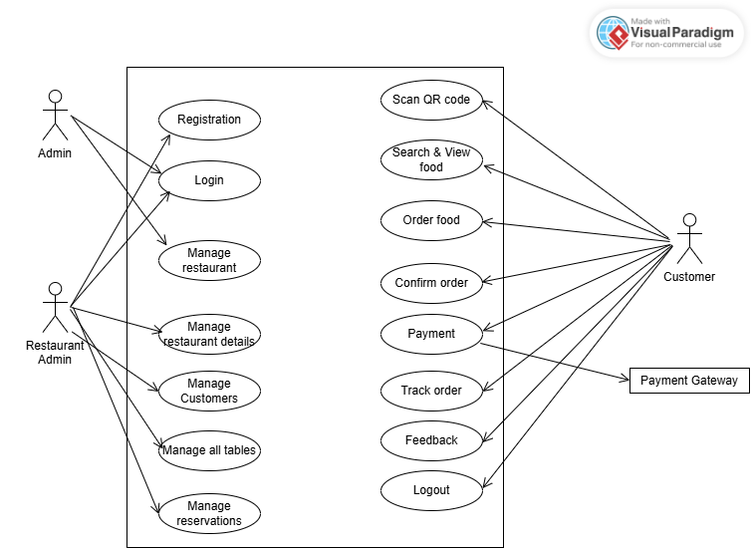
D. Data Flow diagram
1. Context Level diagram
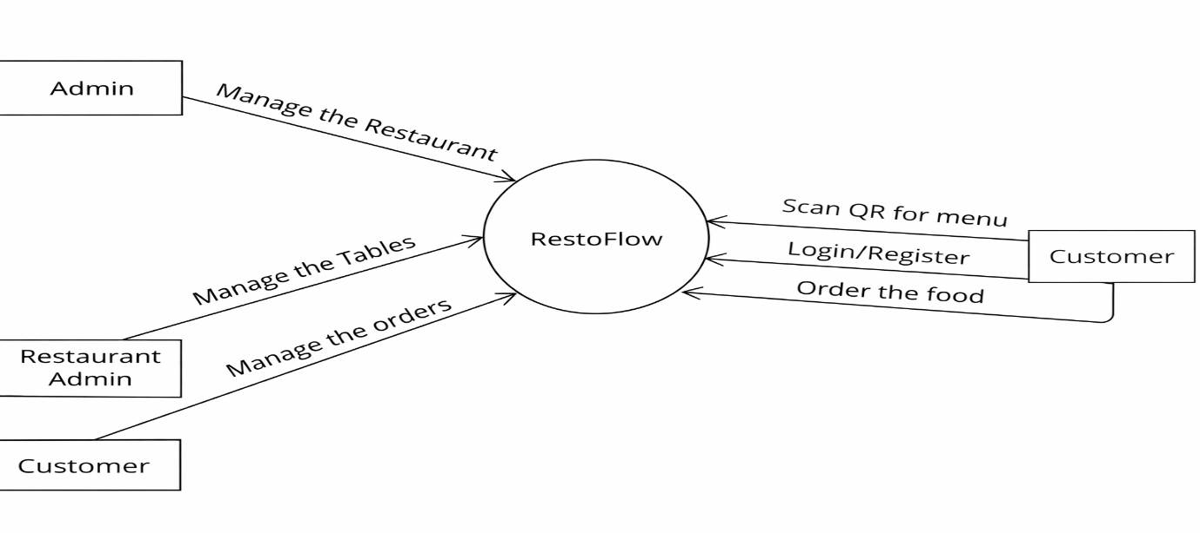
2. Level 1 diagram
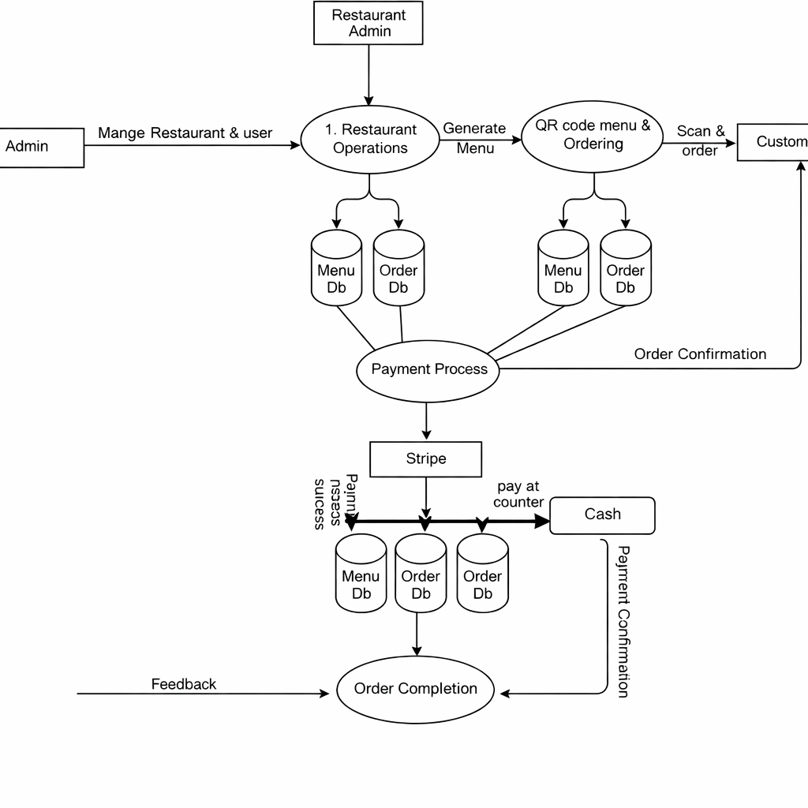
3. Level 2 diagram
a. User Management
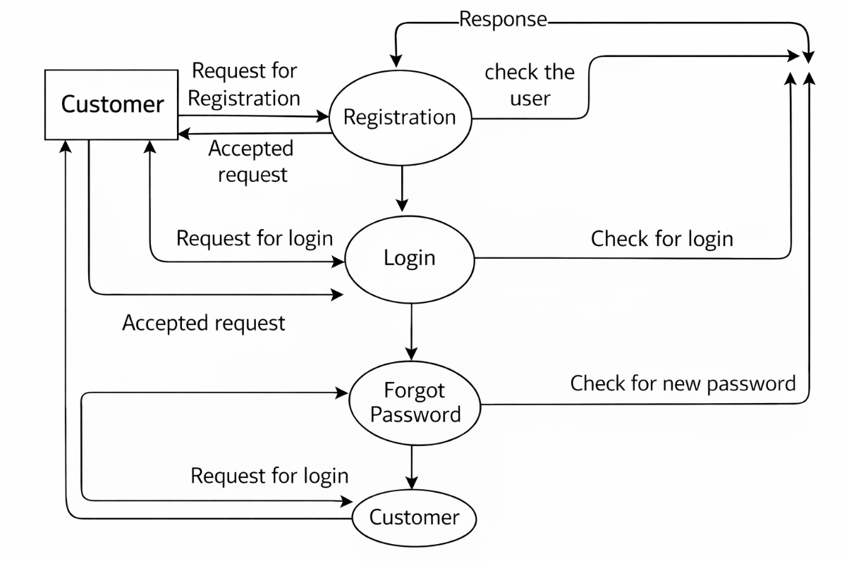
User
b. Menu Management
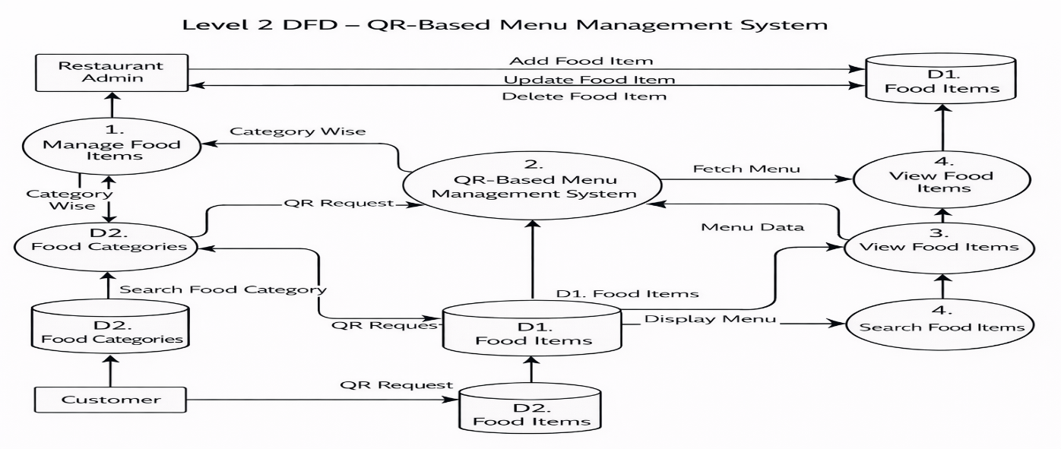
c. Order Management
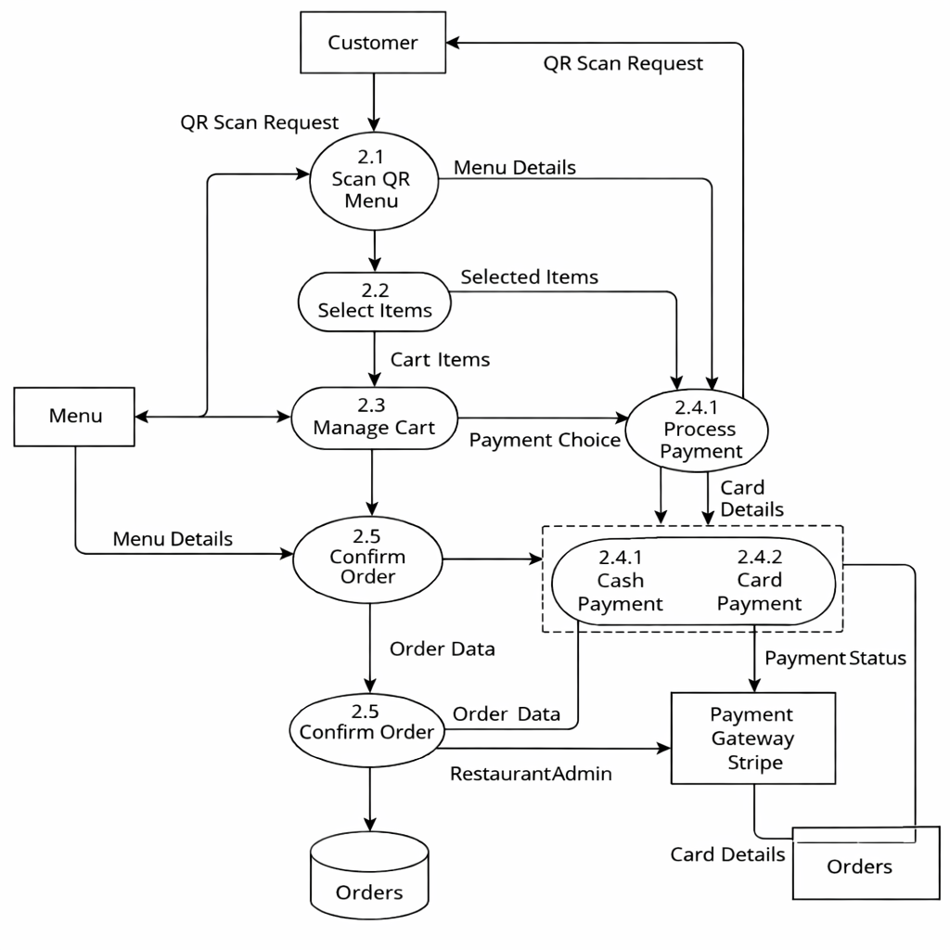
d. Reservation Management
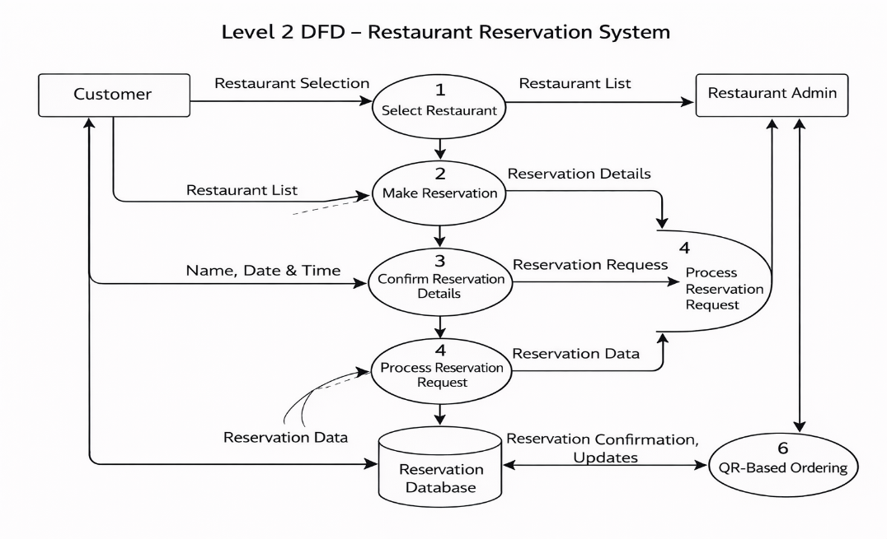

E. System Flow chart
1. Customer/User
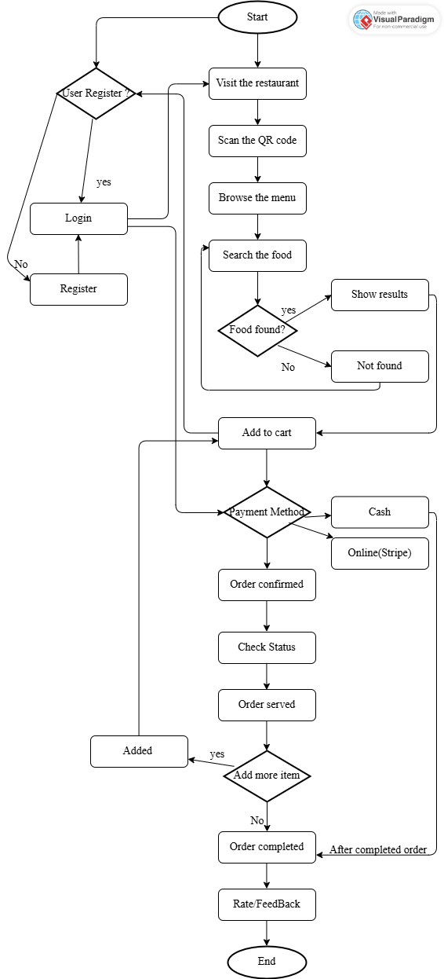
2. Restaurant Admin
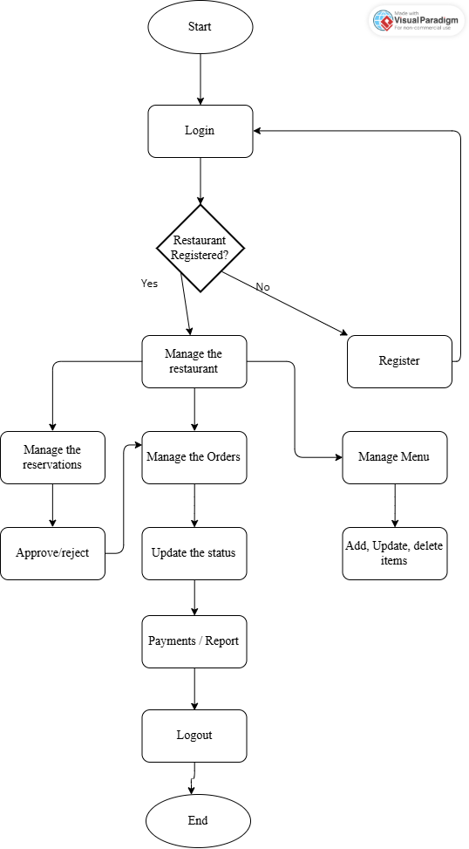

F. Entity Relationship diagram
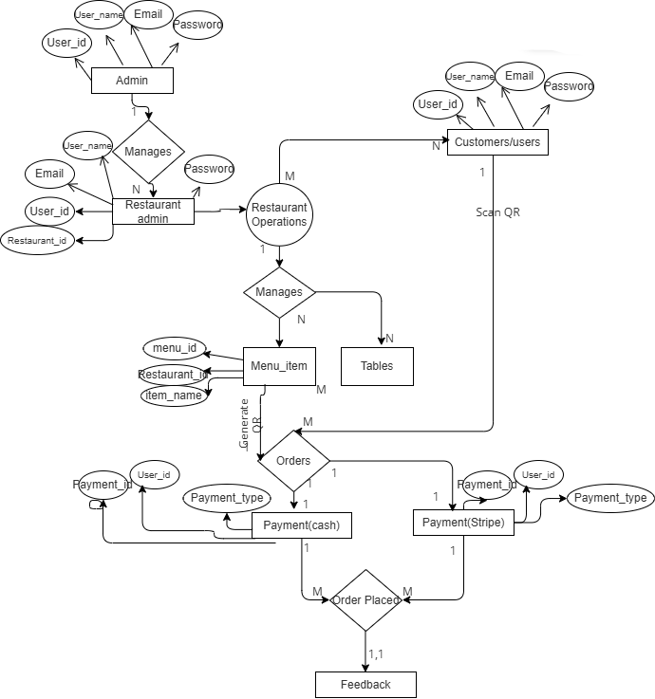

G. Data Dictionary
1. Users Table
Description: Stores all the user related details in this. Role based storage of data.
Sr No | Field Name | Datatype | Constraints | Description
1 | UserId | int | Unique Identifier, Primary Key | Unique ID for all user
2 | FullName | varchar | Not Null | Name of the user
3 | Email | varchar | Not Null, Unique | Email of the user
4 | PasswordHash | varchar | Not Null | Hashed password for the authentication
5 | UserType | varchar | Not Null | Specific user: i.e Admin, Restaurant Admin, Customer
6 | RestaurantId | int | Allow nulls | References from Restaurant
7 | PhoneNumber | varchar | Allow nulls | Number of the user
8 | CreatedAt | datetime | Auto-generated | Timestamp when user was created
9 | OTP | nvarchar | Allow Null, Auto-generated | Generated when login

2. Restaurant
Description: Have all the information related to the restaurant.
Sr No | Field Name | Datatype | Constraints | Description
1 | RestaurantId | int | Unique, Primary Key | Unique for all the restaurants
2 | Name | varchar | Not Null | Restaurant Name
3 | Address | varchar | Allow null | Restaurant Address
4 | Phone | varchar | Allow null | Restaurant Phone Number
5 | OpenTime | time | Allow null | Opening time
6 | CloseTime | time | Allow null | Closing time
7 | IsActive | bit | Not null, Default: 1 | Active status  1: active 0: close
8 | CreatedAt | datetime | Auto-generated | Created Timestamp

3. Tables
Description: All the table related things. Adding table connected with restaurantid with different tableid.
Sr No | Field Name | Datatype | Constraints | Description
1 | TableId | int | Unique, Primary Key | Unique for all the Tables
2 | RestaurantId | int | Not null | Reference from restaurant table
3 | TableNumber | varchar | Not null | Give tables a no. ex: 1,2,3
4 | Capacity | int | Not null | For how many persons’ table
5 | Status | varchar | Not null,  Default:‘Available’ | Check status of the table  Check constraints ('Available', 'Occupied', 'Reserved')
6 | QRCodeUrl | varchar | Not null | Set QR on the table
7 | CreatedAt | datetime | Auto-generated | Created Timestamp

4. Meals
Description: All the meal related things are here stored with restaurantid with different mealid.
Sr No | Field Name | Datatype | Constraints | Description
1 | MealId | int | Unique, Primary Key | Unique for all the Meals
2 | RestaurantId | int | Not null, FK | Reference from the restaurant table
3 | Name | varchar | Not null | Meal name
4 | Description | varchar | Allow null | Items description
5 | Price | decimal | Not null | Items price
6 | Category | varchar | Allow null | Items category wise
7 | ImageUrl | varchar | Allow null | Items image
8 | IsAvailable | bit | Allow null,  Default: (1) | Check availability
9 | IsBestItem | bit | Allow null,  Default: (0) | For best item
10 | CreatedAt | datetime | Auto-generated | Created Timestamp

5. QRCode
Description: Set the QR code with the table id to exactly get order from that table.
Sr No | Field Name | Datatype | Constraints | Description
1 | QRCodeId | int | Unique, Primary Key | Unique for all the Qrcode
2 | TableId | int | Not null, FK | Reference from the tables’ table
3 | QRCodeImageUrl | varchar | Allow null | Set the QR code image
4 | CreatedAt | datetime | Auto-generated | Created Timestamp

6. Orders
Description: With unique order id all the orders are stored here.
Sr No | Field Name | Datatype | Constraints | Description
1 | OrderId | int | Unique, Primary Key | Unique for all the Orders
2 | RestaurantId | int | Not null, FK | References from Restaurant table
3 | TableId | int | Not null, FK | References from tables’ table
4 | CustomerId | int | Not null, FK | References from User table
5 | OrderStatus | varchar | Not null,  Default:(Pending) | For the checking the order status  ('Pending','Preparing','Served','Completed','Cancelled')
6 | TotalAmount | decimal | Allow null,  Default: 0 | Total value of order
7 | CreatedAt | datetime | Auto-generated | Created Timestamp
8 | PaymentStatus | varchar | Allow null,  Default: Pending | For the checking the payment status  ('Pending','Paid','Failed','Refunded')

7. OrderItems
Description: Order Items with total quality and amount are stored here.
Sr No | Field Name | Datatype | Constraints | Description
1 | OrderItemId | int | Unique, Primary Key | Unique for all the OrderItems
2 | OrderId | int | Not null | Reference from order table
3 | MealId | int | Not null | Reference from meal table
4 | Quantity | int | Not null | Add the quality of the item
5 | Price | decimal | Not null | Price of item
6 | TotalPrice | decimal | Allow null | Total price of item

8. Payments
Description: After ordering the payment status related and paid payment with unique transaction is shown here.
Sr No | Field Name | Datatype | Constraints | Description
1 | PaymentId | int | Unique, Primary Key | Unique for all the Payments
2 | OrderId | int | Not null | Reference from order table
3 | Amount | decimal | Not null | Amount to pay
4 | PaymentMode | varchar | Not null | In which mode to pay
5 | PaymentStatus | varchar | Not null,  Default: Pending | Check the payment status
6 | TransactionId | varchar | Allow null | Get the transaction id of the payment
7 | CreatedAt | datetime | Auto-generated | Created Timestamp

9. SavedPaymentMethod
Description: The online card details are stored here that can use other time.
Sr No | Field Name | Datatype | Constraints | Description
1 | SavedPaymentMethodId | int | Unique, Primary Key | Unique for all the Payment
2 | CustomerId | int | Not null, FK | References from the User
3 | StripePaymentMethodId | nvarchar | Not null | Unique Id for all payment method
4 | CardBrand | nvarchar | Not null | Enter the card brand
5 | Last4 | nvarchar | Not null | Saved the last 4 digit of card
6 | ExpMonth | nvarchar | Allow null | Saved the exp month of card
7 | ExpYear | nvarchar | Allow null | Saved the exp year of card
8 | CreatedAt | datetime | Auto-generated | Created Timestamp
9 | LastUsedAt | datetime | Datetime | Put the last date
10 | IsDefault | bit | Allow null,  Default: 0

10. Reviews
Description: After order and payment completion the last step to give the review on the item to the restaurant.
Sr No | Field Name | Datatype | Constraints | Description
1 | ReviewId | Int | Unique, Primary Key | Unique for all the Reviews
2 | RestaurantId | Int | Not null, FK | References from restaurant table
3 | CustomerId | Int | Not null, FK | References from user table
4 | Rating | Int | Not null,  Check from 1 to 5 | Give the rating as on star
5 | Comment | varchar | Allow null | Give the comment
6 | CreatedAt | datetime | Auto-generated | Created Timestamp

11. Reservations
Description: To do reservation in the restaurant than the details need to fill and it is stored here.
Sr No | Field Name | Datatype | Constraints | Description
1 | ReservationId | int | Unique, Primary Key | Unique for all the Reservations
2 | RestaurantId | int | Not null, FK | Reference from restaurant
3 | TableId | int | Not null, FK | Reference from tables’ table
4 | CustomerId | int | Not null, FK | Reference from user table
5 | ReservationDate | date | Not null | Set the date
6 | ReservationTime | time | Not null | Set the time
7 | Duration | int | Not null,  Default: 60 min | Duration to have
8 | NumberOfGuests | int | Not null | Add no of guest to come
9 | Status | nvarchar | Not null,  Default: Pending | See the status of order  ('Pending','Approved','Rejected','Cancelled','Completed')
10 | SuggestedTime | time | Allow null | Give the time back to customer
11 | Notes | nvarchar | Allow null | Add note to manager or restaurant
12 | AdminNotes | nvarchar | Allow null | Give notes to customer by restaurant
13 | CustomerPhone | nvarchar | Not null | To give the phone number
14 | CustomerName | nvarchar | Not null | To give the name
15 | CreatedAt | datetime | Auto-generated | Created timestamp
16 | UpdatedAt | datetime | Auto-generated | Created timestamp

H. Screen Layout with description
1. Home Page of website
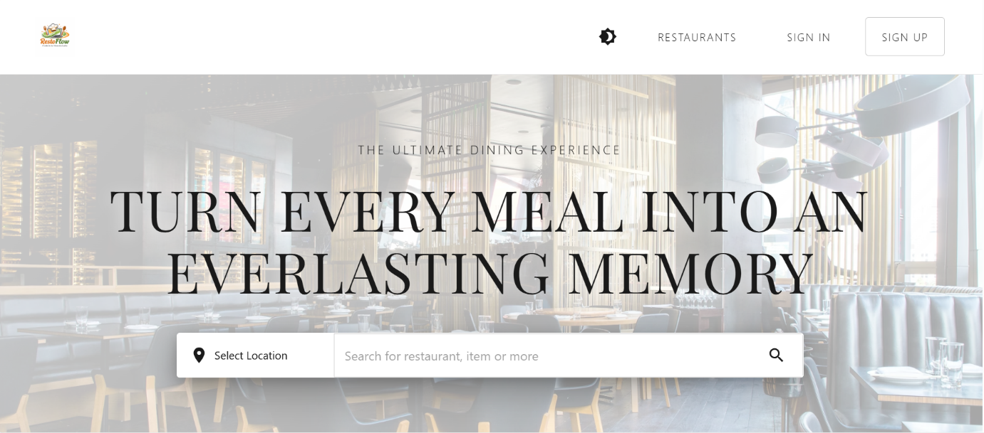
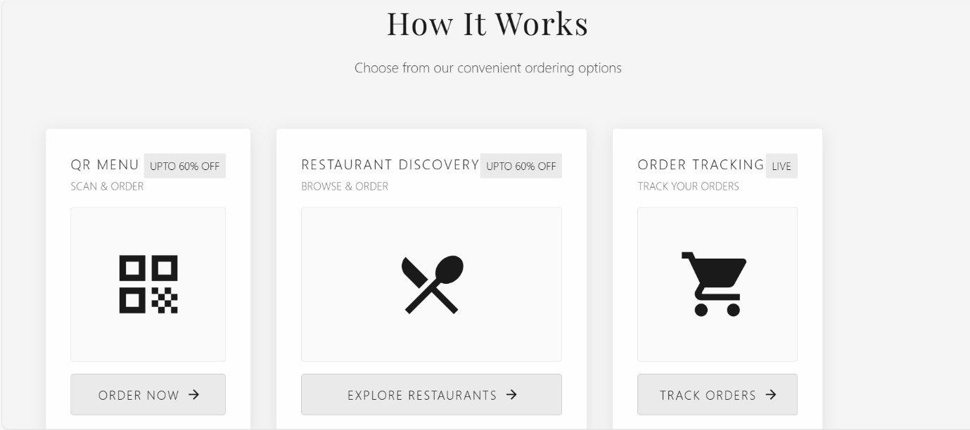
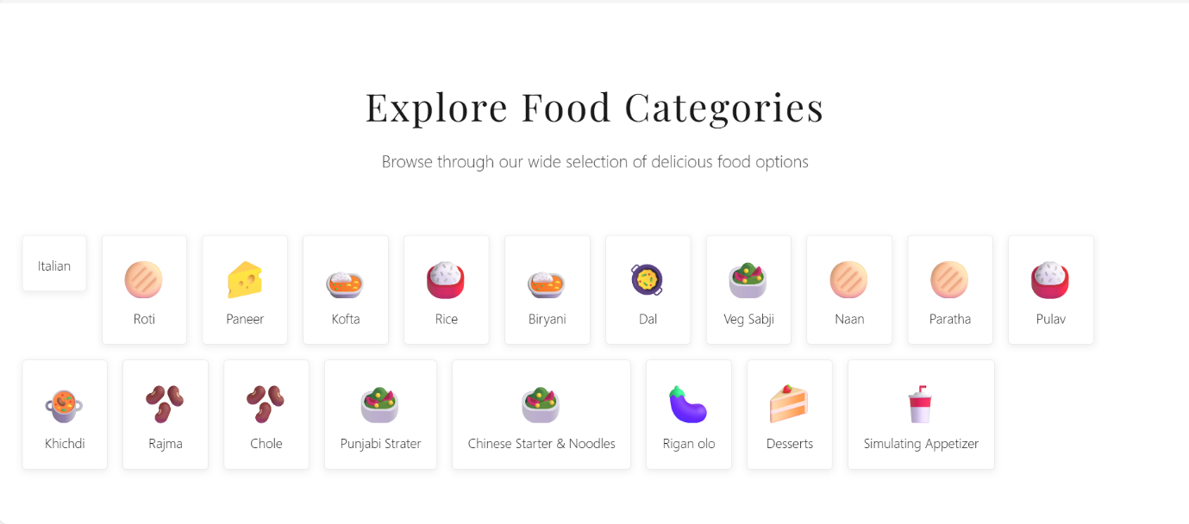
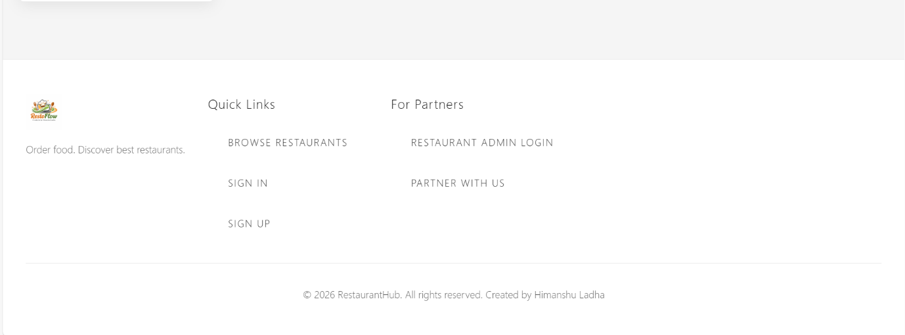
- This is the home page of the system. If we are directly accessing the website then this home page would come from there we can Sign-Up & Sign-in.
- You can search the restaurant, food items, etc things from this.
- It is just for viewing the restaurant and can go if it seems good.
- Here only the at footer there is links for the restaurant admin sign-in & sign-up.

- Customer side
2. Customer Sign-up or Sign-in
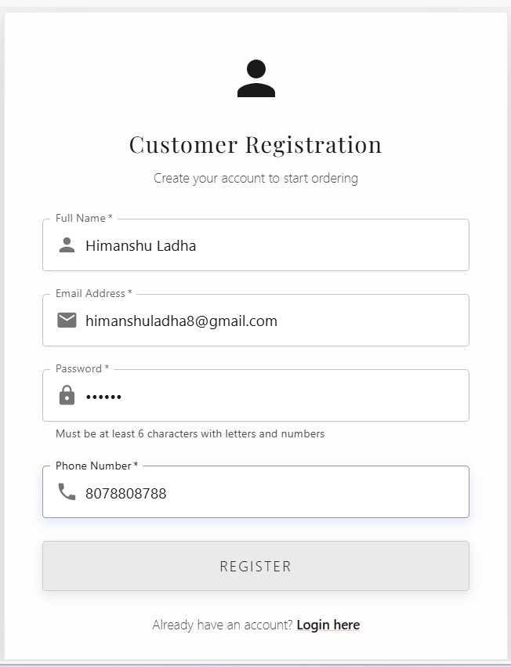
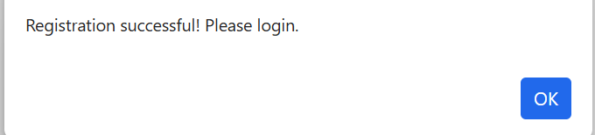
- If new user, there is registration process of that.
- If same email will there it will show error
- Password should be atleast of 6 character with min one alphabet, special character and a number.
- Then the success message will show and redirects to the login page.
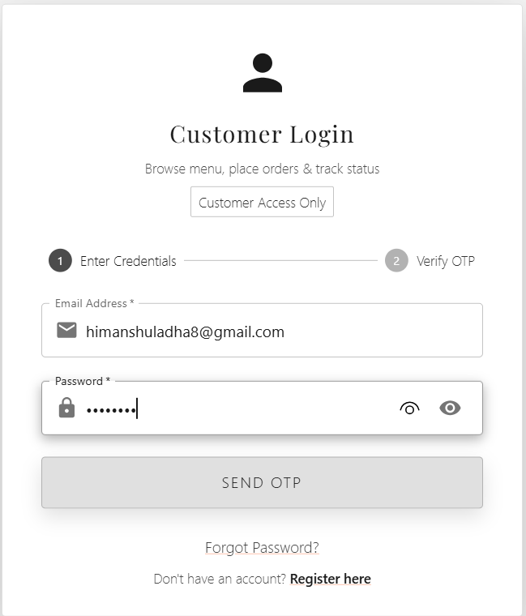

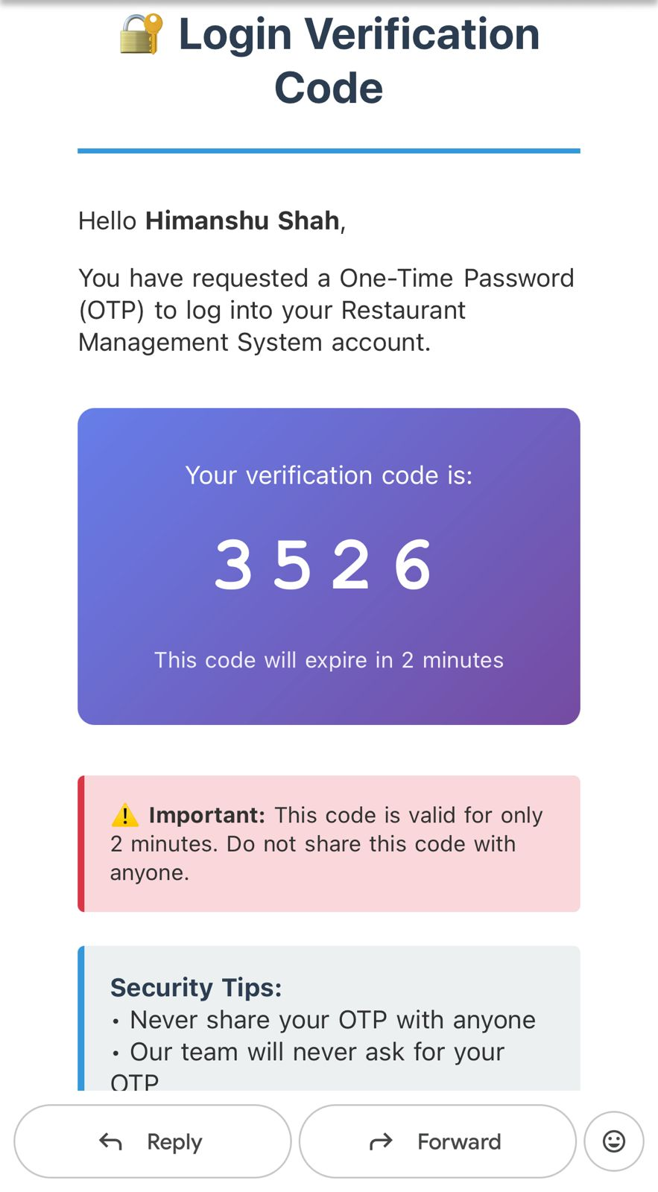
- OTP comes in the mail and we can enter and do login.
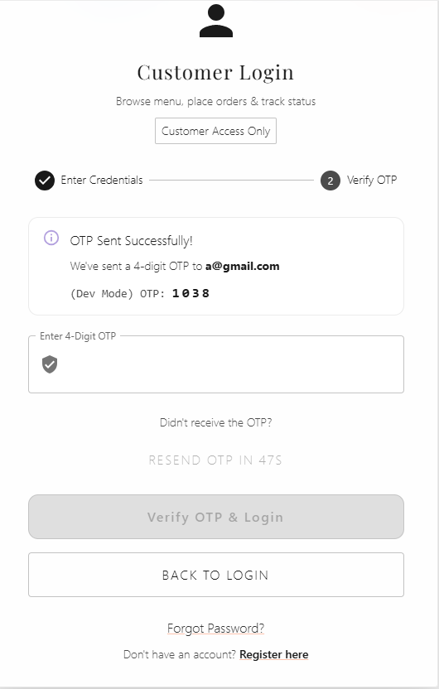
- After getting successful login, the mail would comes. So we can see who login in.
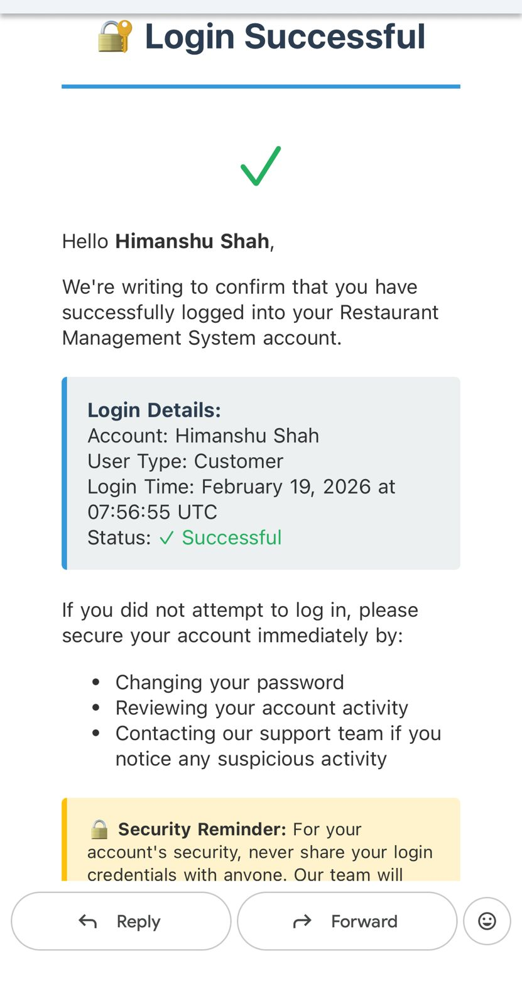
- Forgot Password
We have to enter the email id so we can send the reset password link.
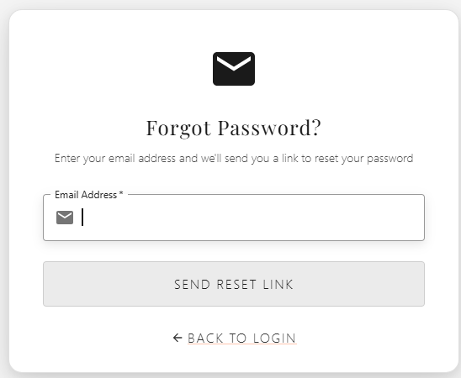
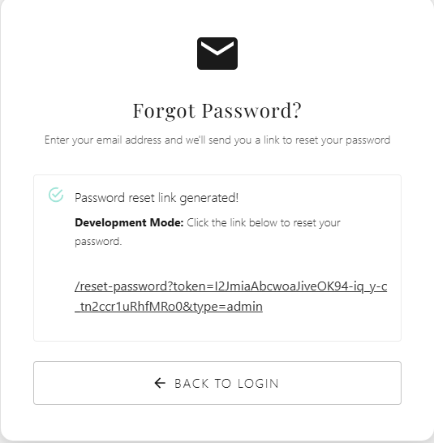
- Click the link so the reset password option would come.

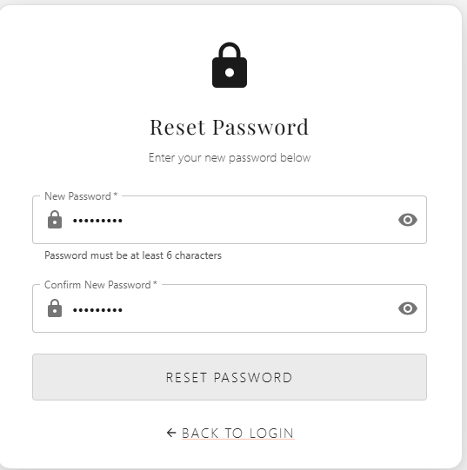
- Enter the new password, so it can changed.
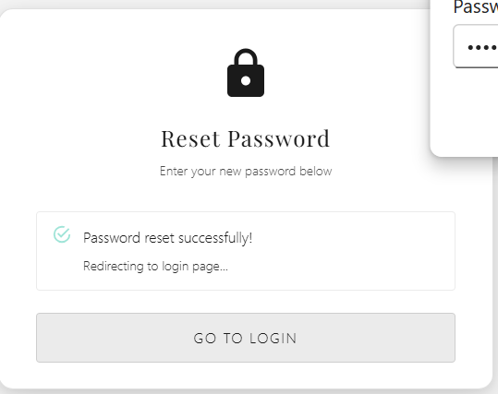

3. User Ordering
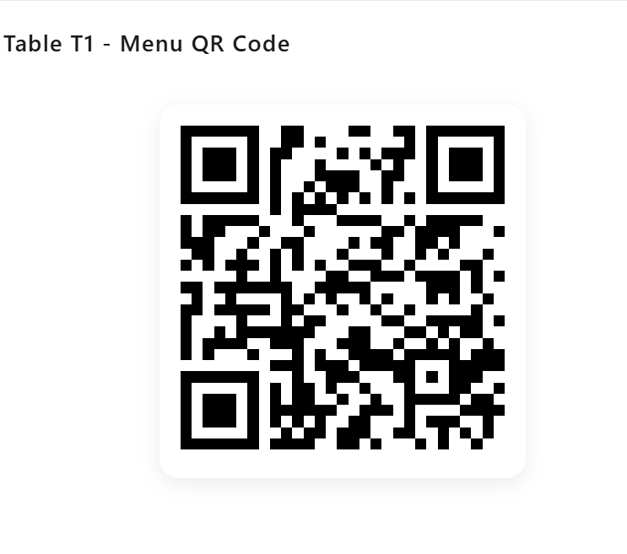
- In restaurant for example, user is seated on table 1 and there is this QR it will scan the QR and will see the menu card.
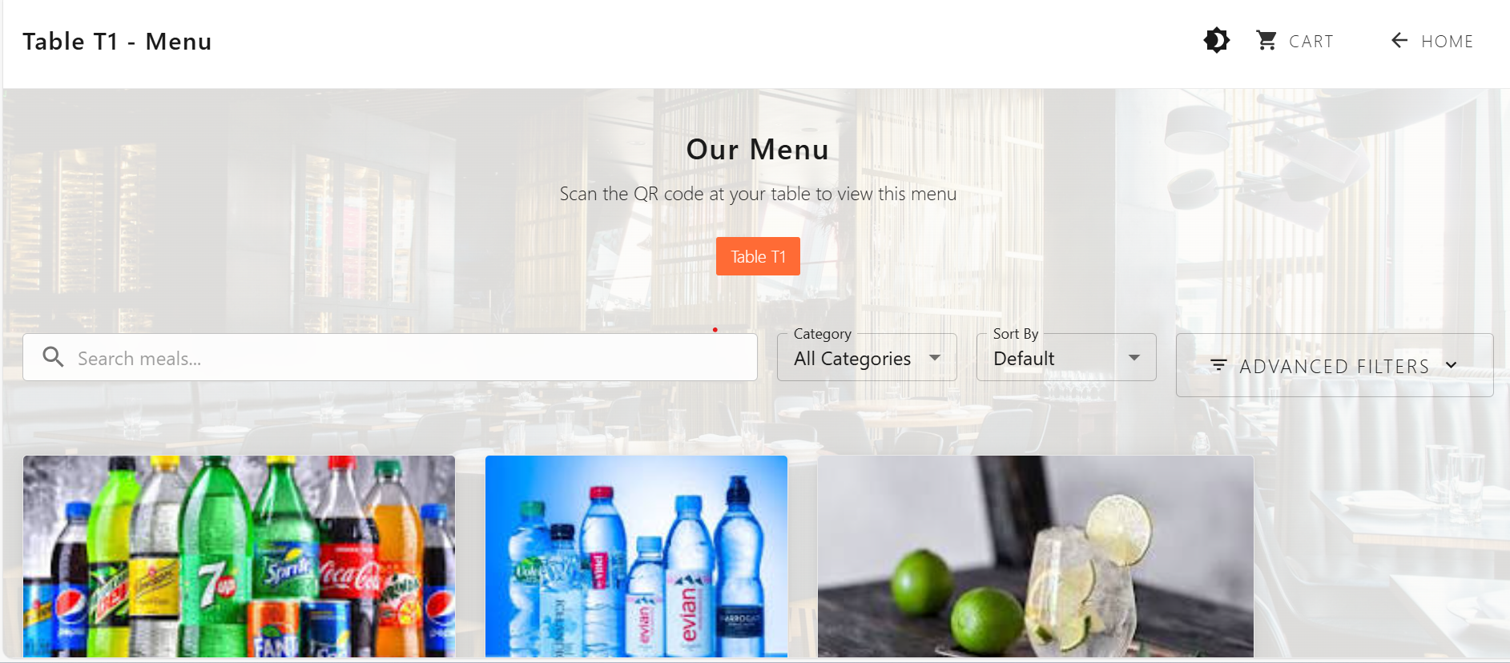
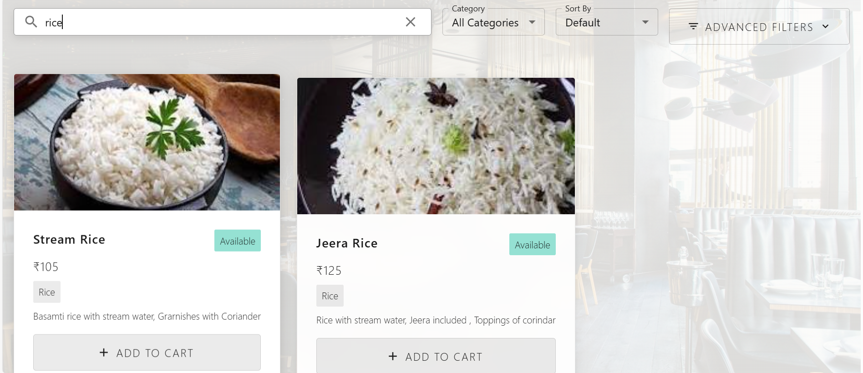
- You can search the food items category wise as well and price range wise.
- Add to cart for view next step.
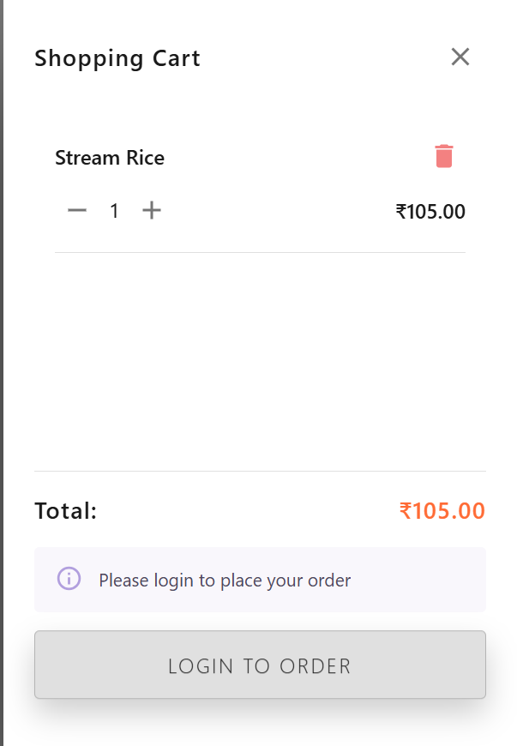
- If user is not login then they will ask for the login here so order will be confirmed.
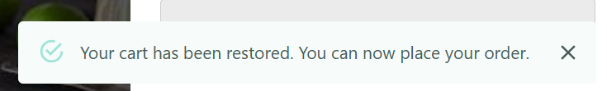
- After login this card will show.
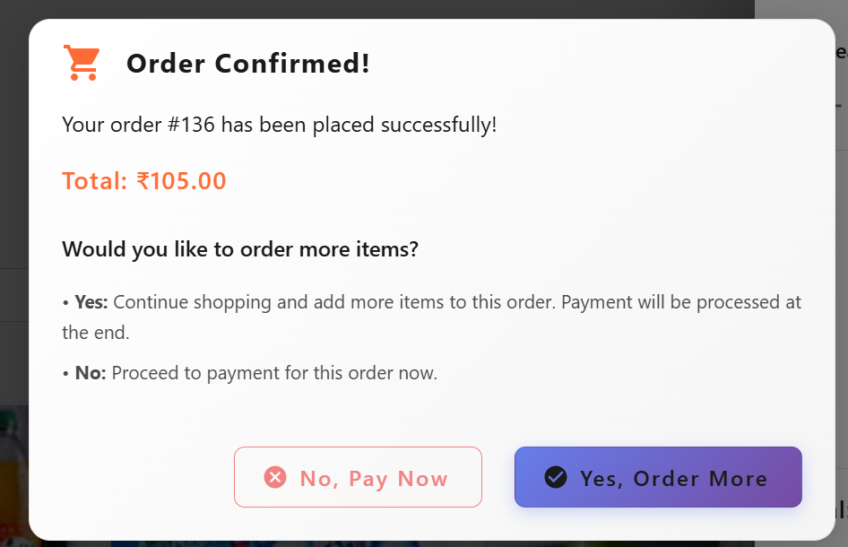
- After placing order, it will ask this No, Pay now or Yes, Order more.
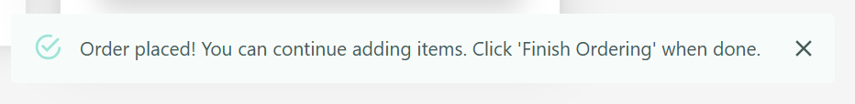
- If if we select order more then it will re-render to menu for more ordering. Previous order will be confirmed.
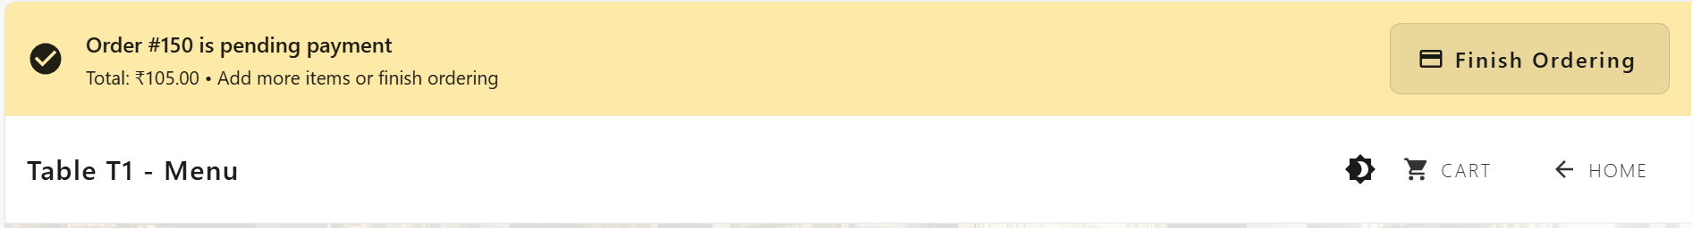
- If after adding then this will show.
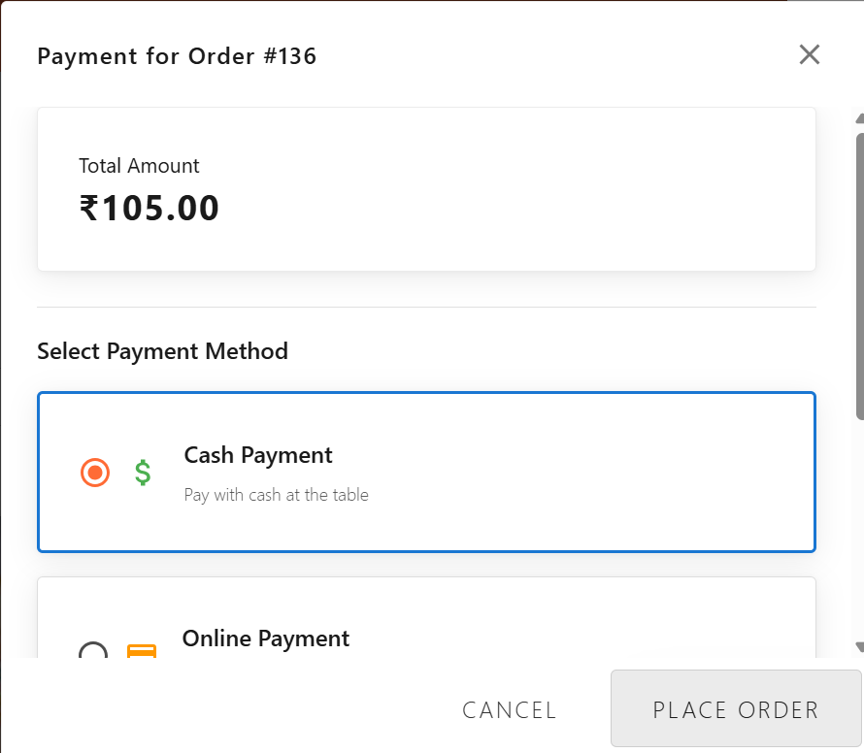

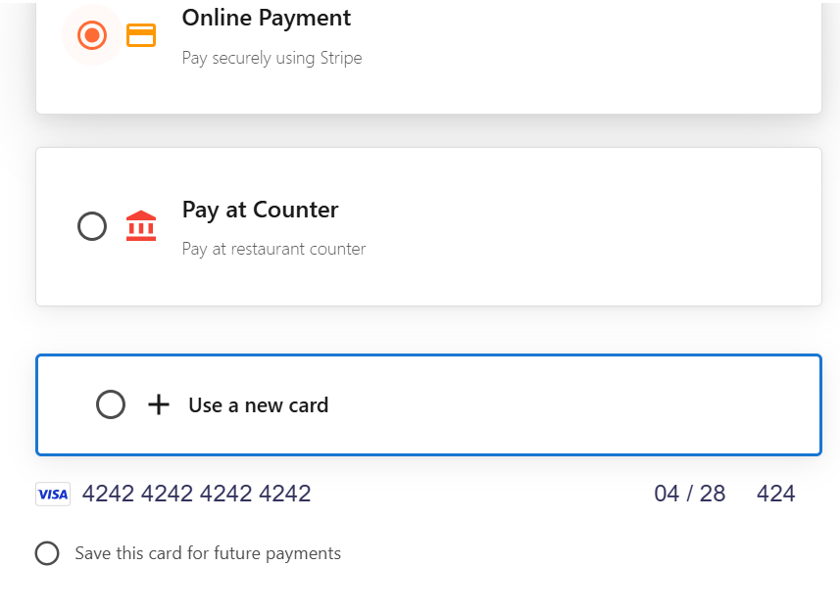
- If we select cash payment then the payment have to done in cash.
- If we select card payment then we need to add the card number for the payment.
- Then pay now so the order will placed.
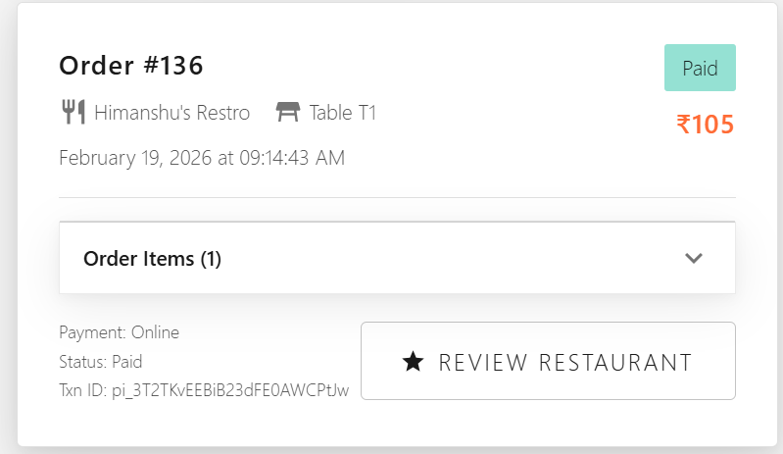

4. Customer Dashboard
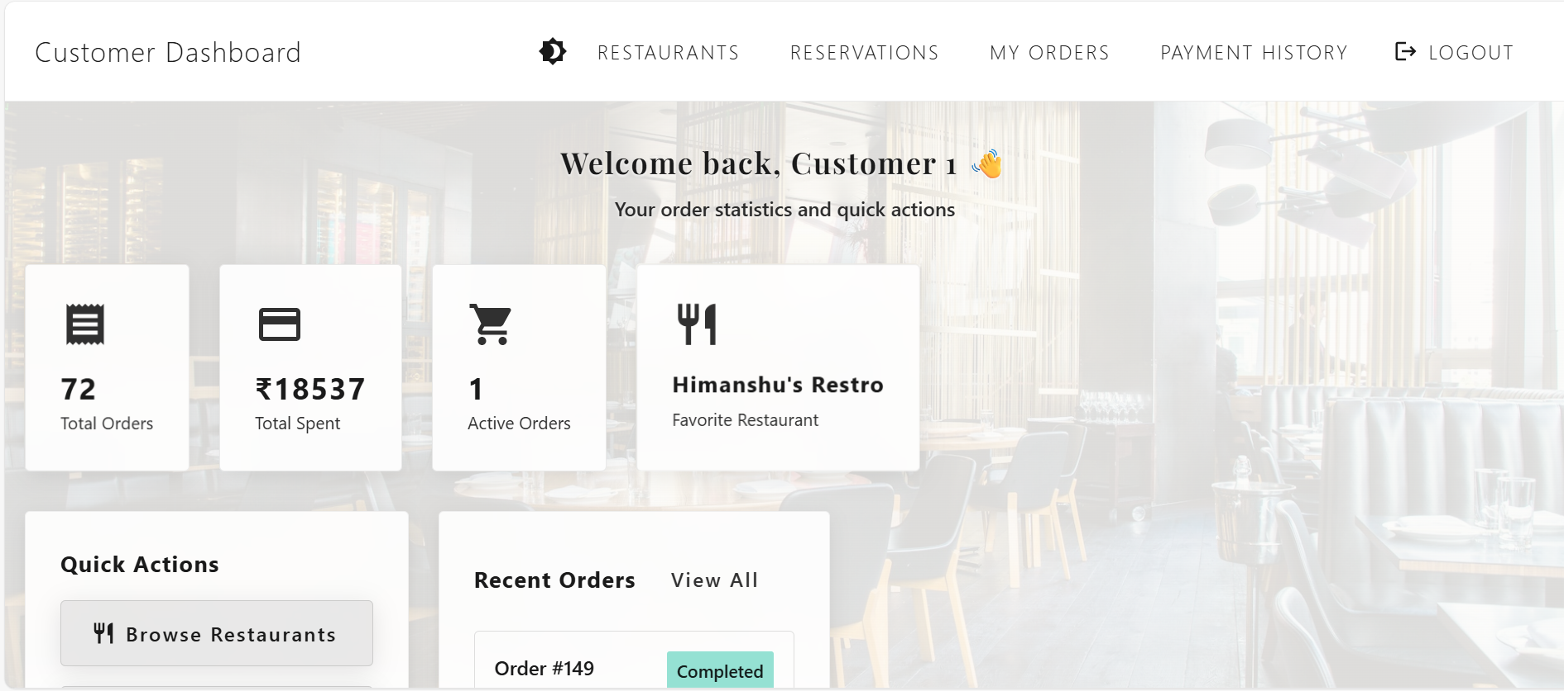

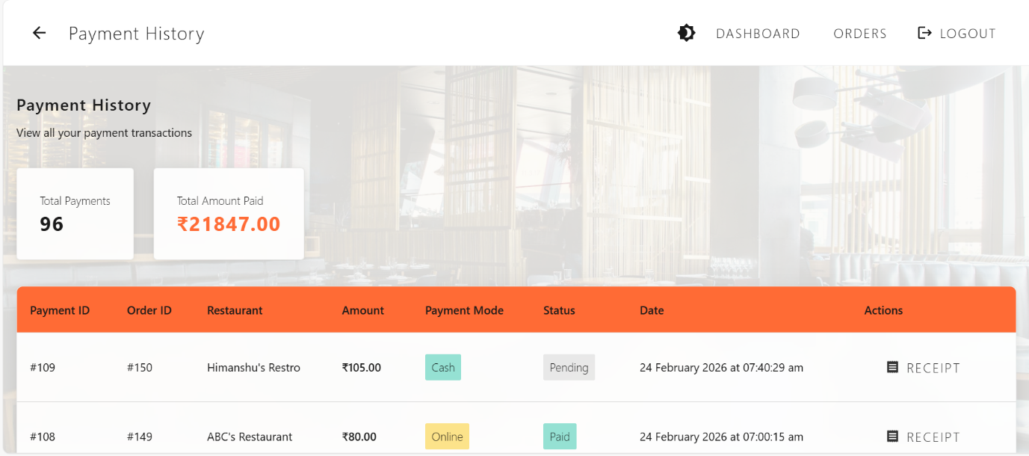
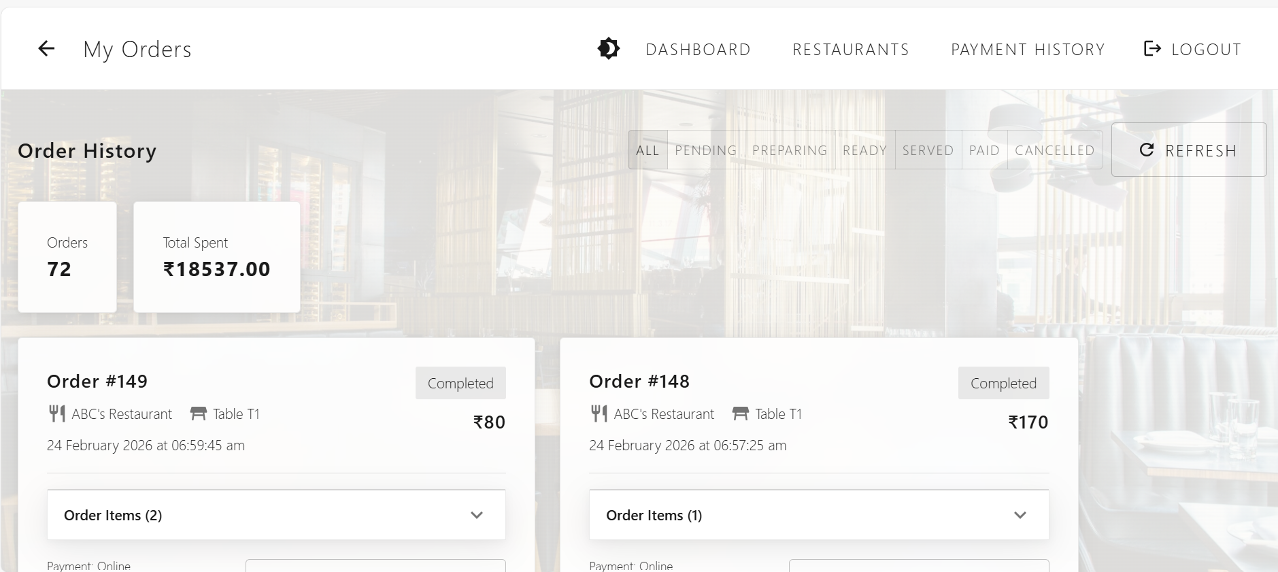

- On Dashboard, we can see the total orders, total spent, active orders etc things
- Payment history , we can see the total payment done and can be see and download the pdf of the bill.
- And lastly in orders we can see the total orders till now we order.

- Restaurant Admin side
5. Restaurant Registration – Sign-up & Sign-in
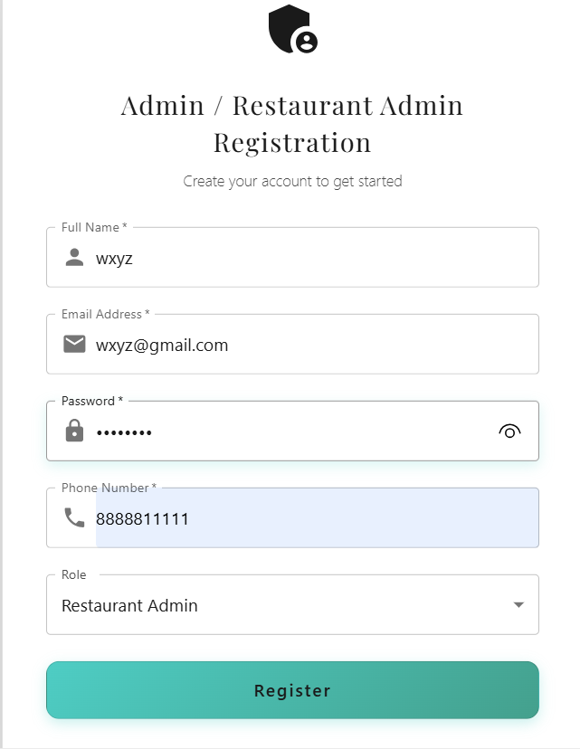
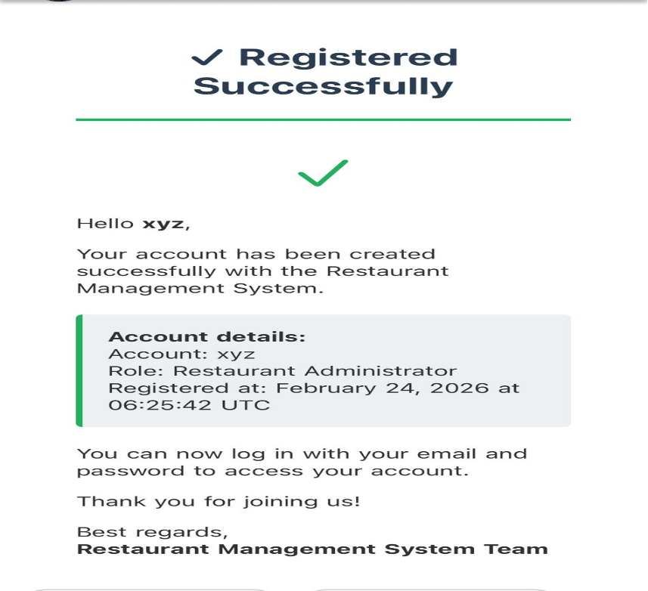
- First need to register with the following information then it will processed further for the details. And the registration success message will come in mail.
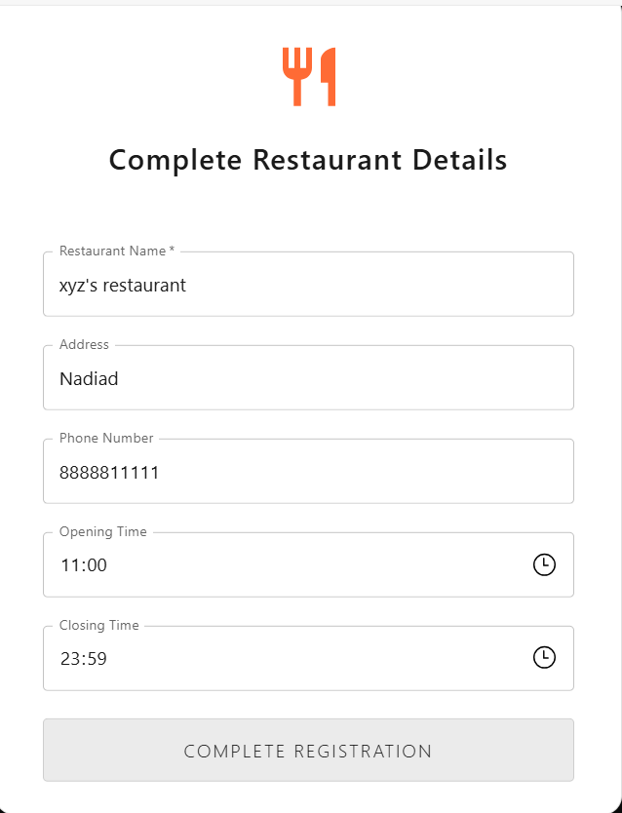

- After Registered it will direct to restaurant details page.
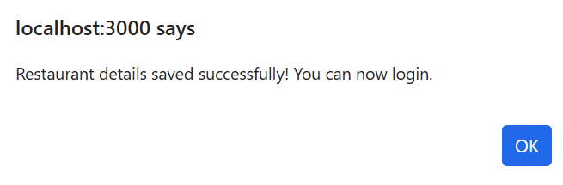
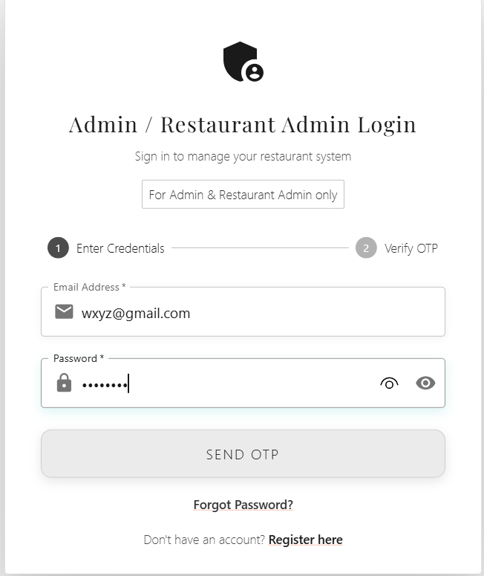
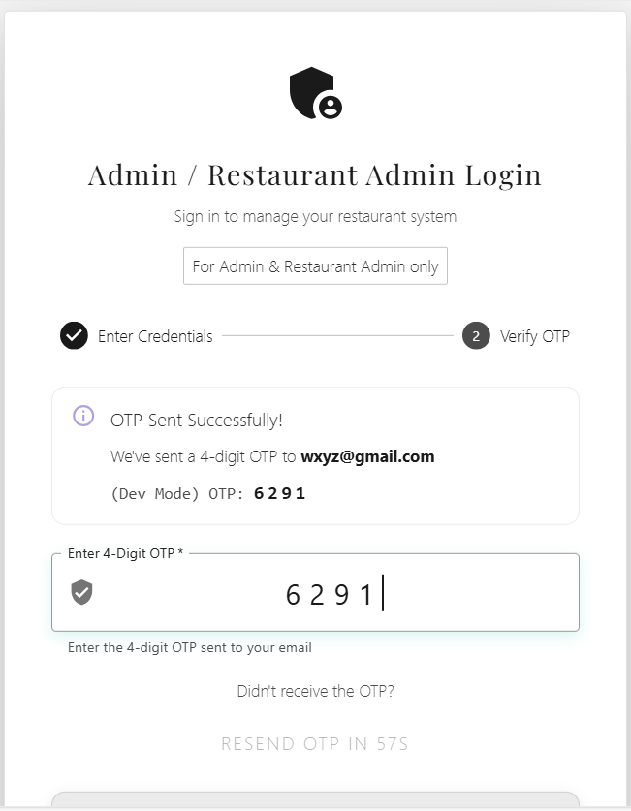
- It is complete login of the system.
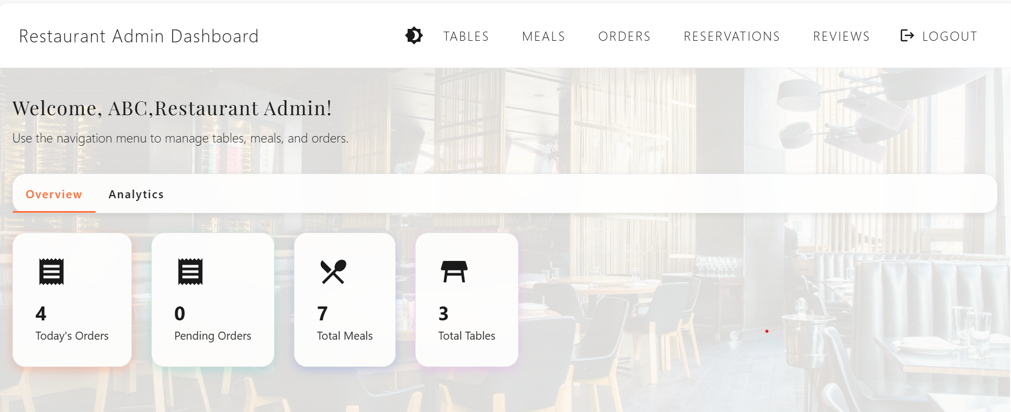
- Dashboard of the Restaurant admin.
6. Adding tables in the restaurant.
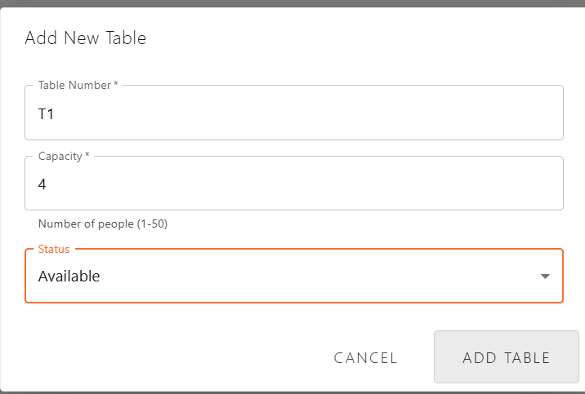

- Table is added here and automatically the QR will generate for that. And you can edit the table also.
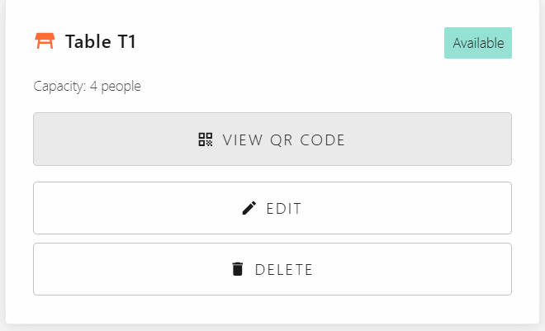
7. Menu item adding.
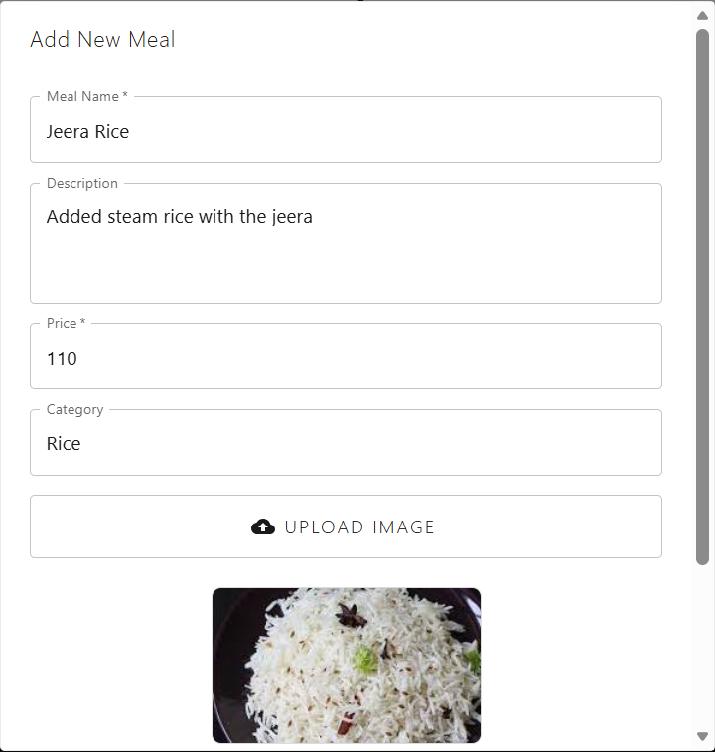
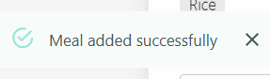
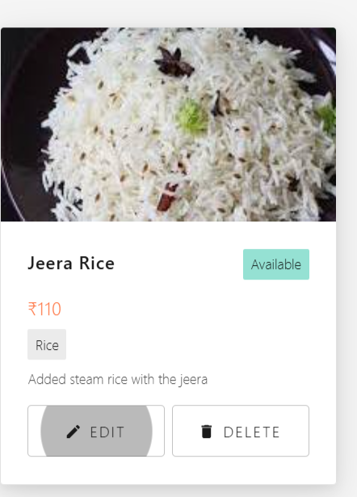
- Meal is added here. And we can update the item as per required. We are setting the meal as per the category wise and adding image also.

8. Order flow in the restaurant dashboard
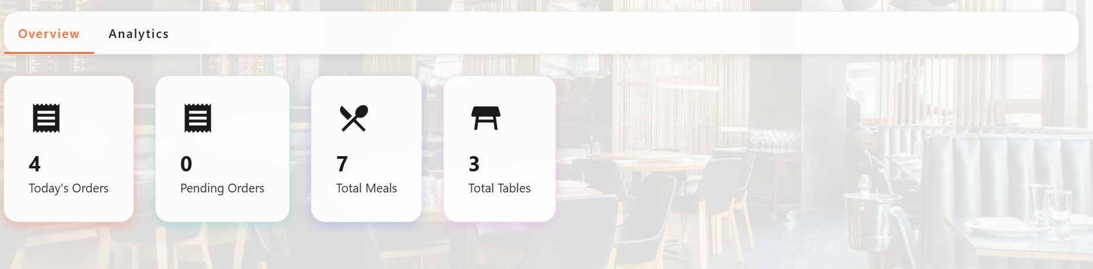
- It will show here as the customer will placed order.
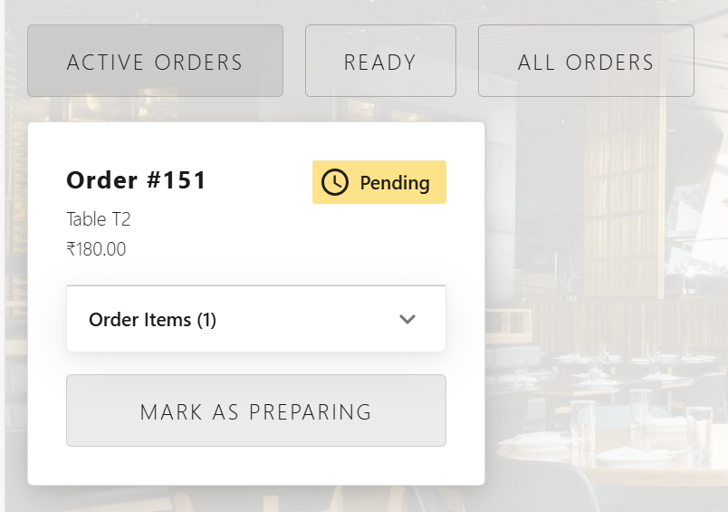
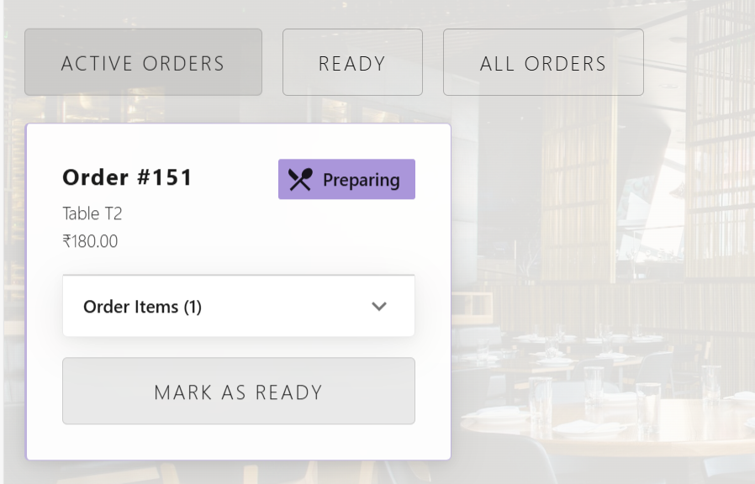
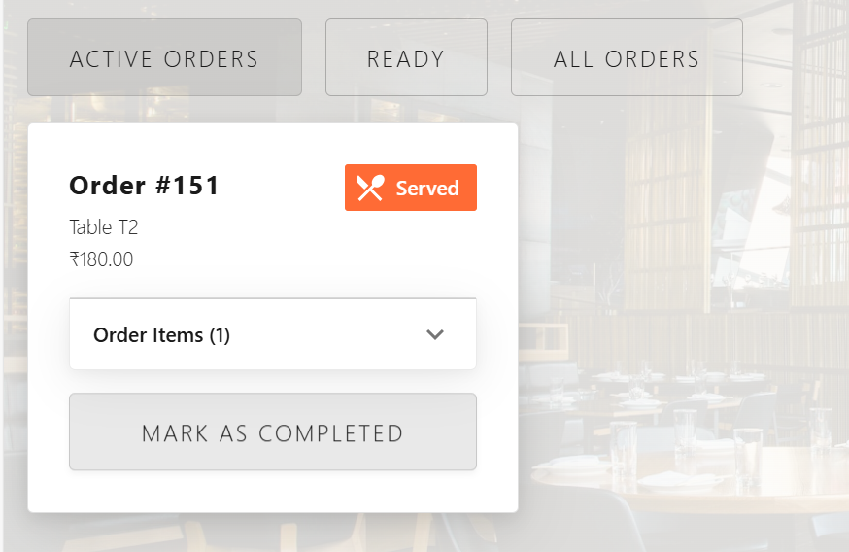
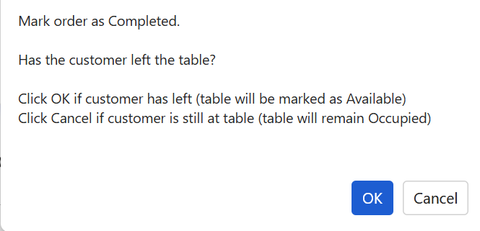

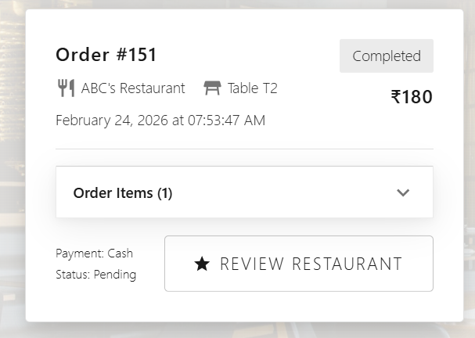
- After clicking on the pending order, the kitchen dashboard will mark Preparing, Ready, Served and Mark as completed as the order will be completed and table will mark as empty again.
9. Reservation System (customer and restaurant side both)
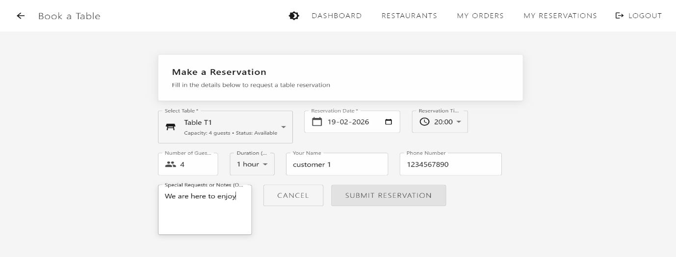
- From customer made reservation and make this request.\
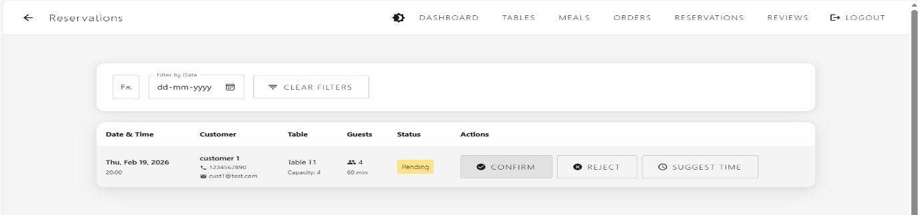
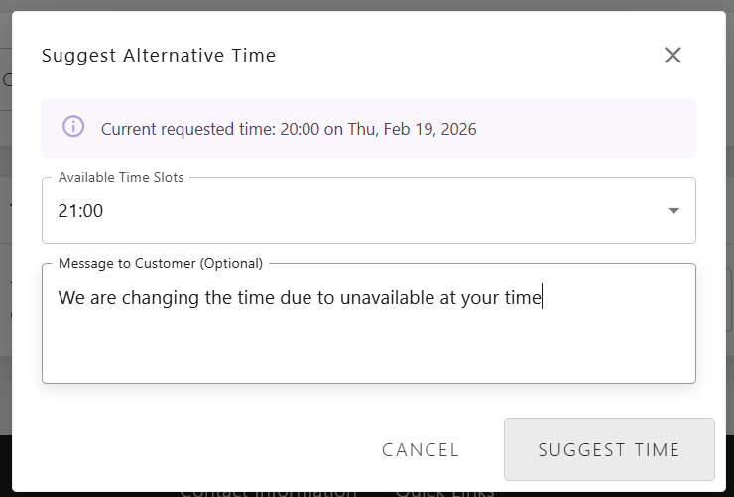
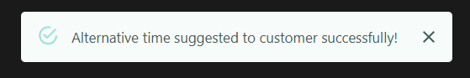
- At the restaurant side notification of this come and there is a option of suggestion time to come. And sended back to customer.
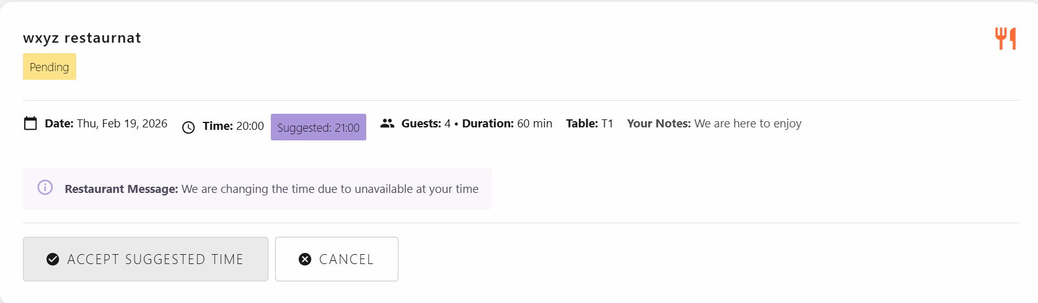

- At the customer side, they will accept the reservation and reservation is confimed.
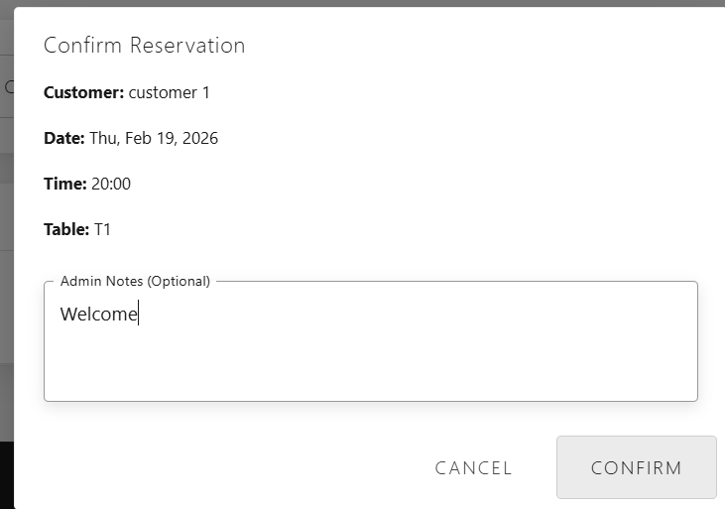
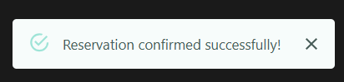
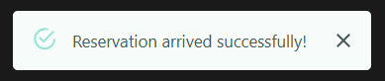
- Restaurant side will confirm the reservation and message will shown.
- At the time of arrival they will mark from their side that they arrived.
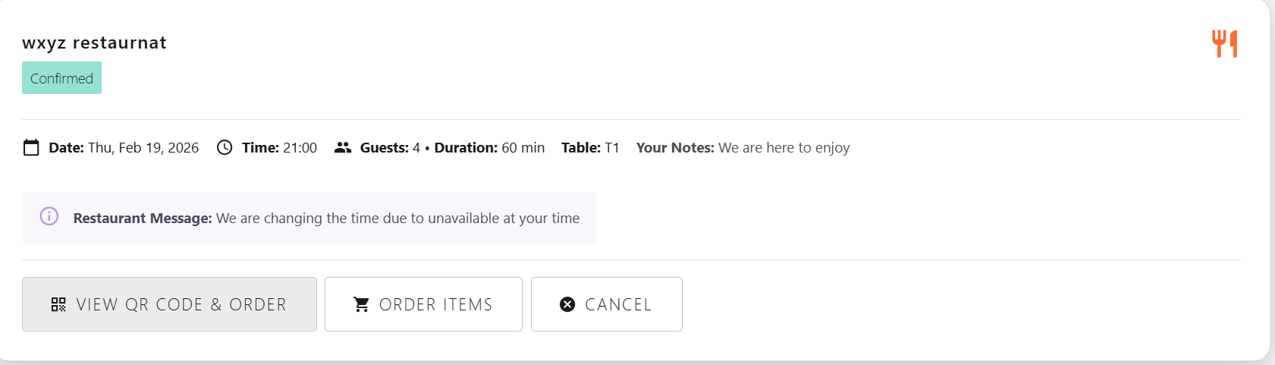
- After arrival mark, they will order from that site only. And the order flow will continue.
10. Restaurant dashboard for Analytics.
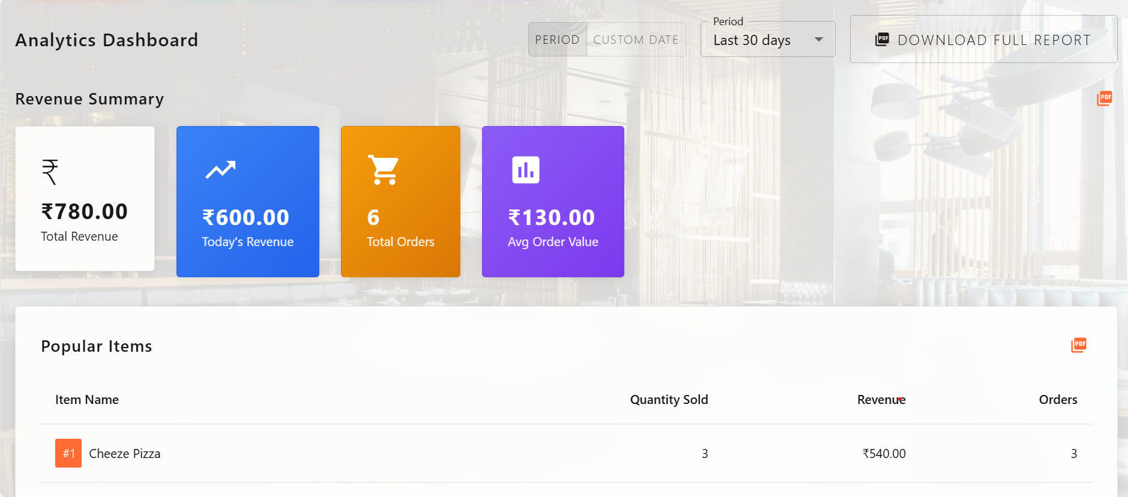
- We can Download the reports in pdf format as full report as well as custom.
- At every card there is pdf option to download that particular report.
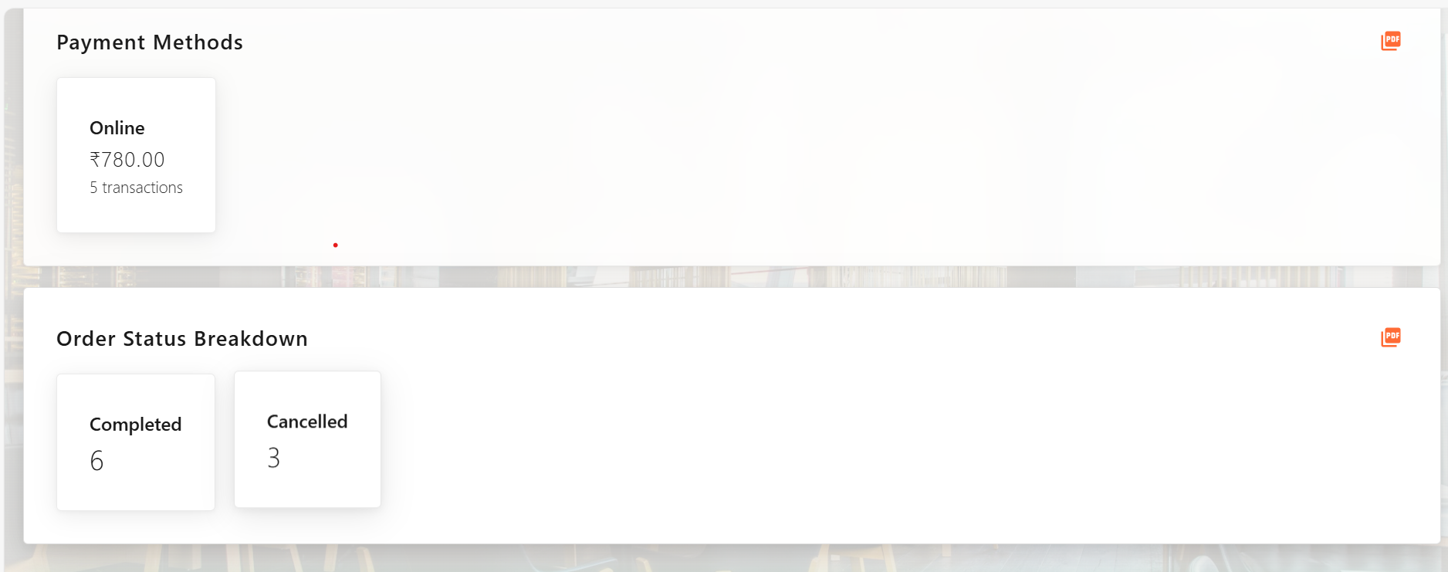
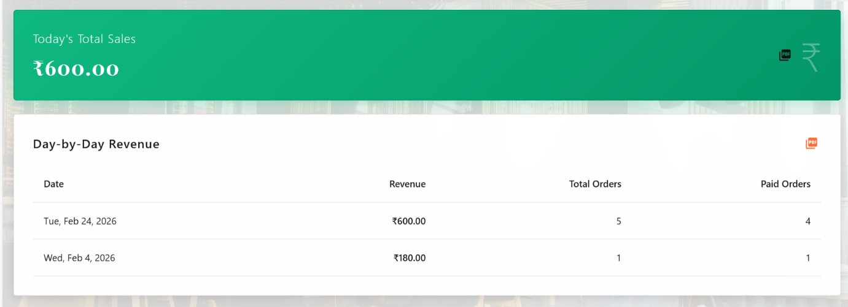
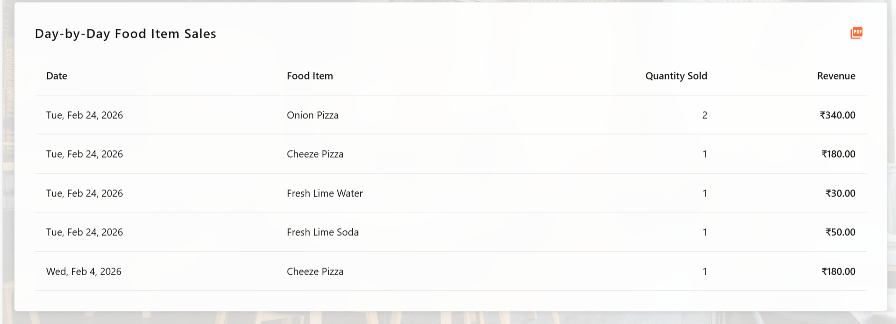

- We can see the summary of the all. Day by day or custom day or Specific period i.e. 30, 60, 90 days.

I. Testing – Test data, Expected result, Actual result
1. Registration ( Admin, RestaurantAdmin, Customer)
Sr No | Field | Test Data (input) | Expected Output | Actual Output | Result
1 | Full Name* | Null | Full name is required | Username is Required | Failed to register
1 | Full Name* | 1234 | Enter alphabet only | Username is Required | Failed to register
1 | Full Name* | Himanshu Ladha | Register successful | Register successful | Register Success
2 | Email* | Null | Email is required | Email is required | Failed to register
2 | Email* | *^@gmail.com | Invalid email | Invalid email | Failed to register
2 | Email* | himanshu@.com | Invalid email | Invalid email | Failed to register
2 | Email* | Himanshuladha8@gmail.com | Valid email | Valid email | Register Successful
3 | Password* | Null | Password is required | Password is required | Failed to register
3 | Password* | him@1 | Invalid Password | Password must be 6 char long | Failed to register
3 | Password* | him@123 | Valid Password | Register successfully | Register success
4 | Phone number* | Null | Number is required | Number is required | Failed to register
4 | Phone number* | 123456789 | Invalid Number | Number should be of 10 digit | Failed to register
4 | Phone number* | 1234567890 | Register Successfully | Register Successfully | Register Success
5 | Role | Admin | Register Successfully | Register Successfully | Register Success
5 | Role | Restaurant Admin | Register Successfully | Register Successfully | Register Success
Note : * field also used for Customer as well.

2. Login (Admin, RestaurantAdmin, Customer)
Sr No | Field | Test data | Expected Output | Actual Output | Result
1 | Email | Null | Email is required | Email is required | Failed to Login
1 | Email | *^@gmail.com | Invalid email | Invalid email | Failed to Login
1 | Email | himanshu@.com | Invalid email | Invalid email | Failed to Login
1 | Email | Himanshuladha876@gmail.com | Email doesn’t match | Invalid email | Failed to Login
1 | Email | himanshuladha8@gmail.com | Valid email | Valid email | Login Success
2 | Password | Null | Password is required | Password is required | Failed to login
2 | Password | him@1 | Invalid Password | Password must be 6 char long | Failed to login
2 | Password | him@12 | Valid Password | Valid Password | Login Success
3 | OTP | Null | OTP is required | OTP is required | Failed to login
3 | OTP | 1234 | Invalid OTP | Invalid OTP | Failed to login
3 | OTP | 1222 | Valid OTP | Valid OTP | Login Success
Note : Login field is same for Admin, RestaurantAdmin, Customer
3. Forgot Password
Sr no | Field | Test Data | Expected Output | Actual Output | Result
1 | Email | Null | Email is required | Email is required | Failed to Login
1 | Email | *^@gmail.com | Invalid email | Invalid email | Failed to Login
1 | Email | himanshu@.com | Invalid email | Invalid email | Failed to Login
1 | Email | Himanshuladha876@gmail.com | Email doesn’t match | Invalid email | Failed to Login
1 | Email | himanshuladha8@gmail.com | Valid email | Valid email | Login Success
2 | New Password | Null | Password is required | Password is required | Failed to change
2 | New Password | him@1 | Invalid Password | Password must be 6 char long | Failed to Change
2 | New Password | him@12 | Valid Password | Valid Password | Enter the New password
3 | Confirm New Password | Null | Password is required | Password is required | Failed to Change
3 | Confirm New Password | him@1 | Invalid Password | Password should be same | Failed to Change
3 | Confirm New Password | him@12 | Valid Password | Valid Password | Password changed successfully

CHAPTER – 7
SCOPE AND LIMITATIONS

Scope and Limitations
- Scope of RestoFlow:-
RestoFlow is a digital restaurant ordering system that allows users to scan a QR code on the table to view the menu, place orders, and make payments instantly. And made the restaurant operations easily.
1. User-Oriented Features
- Enables customers to easily browse the menu, place orders, and make payments.
- Saves time by eliminating the need for manual order taking.
- Provides search filters and category-wise menu browsing.
- Maintains order history for a better user experience.
- Offers secure and flexible payment options.
2. Restaurant Management
- Allows restaurants to manage orders, food items, and other operational activities efficiently.
- Provides real-time order status updates to customers at each stage.
- Collects customer feedback and reviews for service improvement.
- Generates customized reports based on revenue, sales, and selected date ranges.
3. Admin Management
- Enables the system administrator to manage all restaurants and users.
- Allows adding, updating, or removing inappropriate content.
- Monitors restaurant transactions and overall system activities.
4. Security and Authentication
- Implements JWT-based secure authentication.
- Provides role-based access control (Admin / Restaurant Admin / Customer).
- Ensures encrypted password storage.
- Supports secure payment processing.
- Protects API endpoints from unauthorized access.
5. Revenue Model
- Operates on a commission-based model from partner restaurants.
- Promotes the platform to attract more restaurants and expand market reach.
6. Future Growth & Scalability
- Integration of AI-based food recommendations.
- Expansion to support multiple secure payment methods.
- Scalable architecture to support increasing users and restaurants.

- Limitations
1. Payment Methods: Currently, payments are accepted only through Stripe and cash. Other payment options such as UPI, digital wallets, etc., are not yet integrated into the system.
2. AI Integration: Artificial Intelligence is not yet implemented in the system; therefore, it does not provide item recommendations or personalized suggestions.
3. Internet Connectivity: A proper and stable internet connection is required for smooth and secure ordering and payment processing.
4. Maintenance Requirements: The system requires regular maintenance, including bug fixes, security patches, and database management, to ensure efficient and continuous operation.
5. Scalability Constraints: The system may face performance issues if a large number of users access it simultaneously without proper server scaling and optimization.
6. Limited Offline Functionality: The system does not support offline operations, meaning all features depend entirely on real-time internet access.

CHAPTER – 8
FUTURE EXPANSION

Future Expansion

1. AI & Smart Features:
The system will integrate Artificial Intelligence to provide advanced features such as food recommendations, identification of most-selling items, analysis of peak restaurant hours, and personalized recommendations based on customer food preferences.
2. Customer Features:
A reward points system will be introduced for each order placed by customers. Discount coupons and membership benefits will also be added, offering special discounts for premium customers.
3. Multi-Branch Management:
For restaurants with multiple branches, the system will provide centralized access to reports and restaurant-related operations for all branches. This will help in better monitoring and management across locations.
4. Mobile Applications:
A dedicated mobile application for customers will be developed to enhance usability and convenience. The app will include features such as order tracking, notifications for offers, and promotional updates.
5. Enhanced Security:
Additional security features will be implemented to make the system more secure and ensure better protection of user data and transactions.
6. Ads and promotions:
Online advertisements and promotional campaigns will be implemented to increase website visibility and attract more users.

